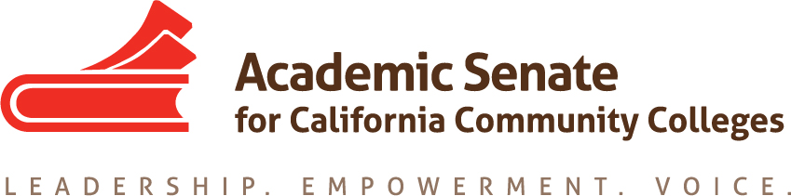

ACADEMIC SENATE FOR CALIFORNIA COMMUNITY COLLEGES
AREA B MEETING
Friday, 1 April 2016
10:00 - 3:00 (Continental Breakfast at 9:30)
College of Marin
Academic Center Room 255
Dolores’ Cell: 408.230.7730

- Welcome and Introductions

- Area B meeting for Fall 2016–Solano College
  - Spring 2017 meeting - Location?

- Resolutions
  - Resolutions process overview –Rochelle Olive, ASCCC Resolutions Committee
  - Review and discussion of pre-session resolutions; http://www.asccc.org/events/2016-04-21-150000-2016-04-23-230000/2016-spring-plenary-session (Click on Resolutions)
  - Development and discussion of any Area B resolutions or amendments

- Reports (given during lunch)
  - ASCCC Update – Julie Bruno, Vice President, ASCCC
    - Budget
    - Legislative Updates
  - Academic Senate Foundation for CCC Update
  - Disciplines List
  - Executive Committee Elections
    - Announcement
    - Intent Form
  - Volunteering for Statewide Service

- Reports From Colleges

- Announcements
  - Meetings/Institutes – Registration Now Open!
  - 1. Online Education Regional Meeting – April 8-9, North and South
  - Noncredit Regional Meeting – April 15-16, North and South
  - Spring Plenary – April 21-23, Sacramento Convention Center
  - CTE Leadership Academy – May 6-7, Anaheim Doubletree Hilton
  - Leadership Institute – June 9-11, Riverside Mission Inn
- Adjournment – See you at plenary!

