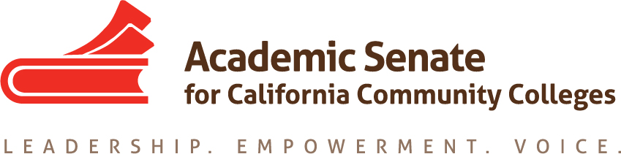

ASCCC ONLINE EDUCATION COMMITTEE

AUGUST 30TH, 2019

9:00AM – 10:00AM

ZOOM

Meeting Summary

Present: Carrie Roberson (Chair), Geoffrey Dyer (Second), James “Marty” Rudd, Phylise Smith, Ingrid Greenberg, May Sanicolas

- Call to Order
Carrie Roberson called the meeting to order at 9:00am. Geoffrey Dyer was designated the notetaker.
  - Welcome & Introductions
Carrie thanked the committee for their service, and each member introduced themselves and referred to relevant professional experiences that they would inform their work on the committee. James Rudd indicated that his preferred name is Marty.

- Adoption of the Agenda
The committee adopted the agenda by unanimous consent.

- Approval of Minutes
  - Previous meeting summaries are already approved. The committee agreed that it would use consensus-style decision making. Geoffrey volunteered to share draft minutes subsequent to meetings for prompt review by the committee.

- Links
  - Application for Statewide Service
Carrie asked the committee to encourage other faculty to complete the application for statewide service and emphasized the importance of faculty leadership.
  - ASCCC Online Education Committee
Carrie oriented the committee with the public-facing ASCCC Online Education Committee page.

- Action Items
  - Review Online Education Committee Roster
The committee reviewed the roster to ensure that roster was current. James Rudd’s name was changed to Marty, his preferred name.

  - Review Online Education Committee Charter:
The committee reviewed the committee’s charge. Carrie suggested that if the committee determines this year that changes are needed, the committee could update the charge in spring to be effective for next fall.

  - Assigned Resolutions
    - Resolution 11.01 S17: Using Savings from Adopting Canvas
Carrie showed the committee how to use the Resolutions feature of the ASCCC site. She reviewed the

status report of the resolution. The savings from districts adopting Canvas are likely absorbed by districts. Ingrid expressed the desire to investigate locally how funds that used to fund their CMS were now used. Phylise agreed that she would also like an update.

  - Assigned Tasks
    - Rostrums, Resolutions
Carrie and Geoffrey reviewed the Resolutions Process. Carrie indicated that Rostrum articles are due on September 27.

  - Meetings dates/times
    - Virtual, fall meetings:
Sept. 24, 12-1; Oct. 21, 12-1, Nov. 22, 12:00pm-1:00pm
    - Face-to-face meeting:
In Sacramento in January 14

- Action Items
  - ASCCC Strategic Plan
    - Faculty Diversification, Shared Governance, Guided Pathways
Carrie informed the committee of the ASCCC Strategic Plan and the ASCCC’s goals for 2019-2020.

  - Committee Priorities-
Carrie asked the group to review these recommended priorities and consider future direction or if additional priorities were needed. Brief discussion of the new DE Guidelines.

    - The new definitions contained within the DE guidelines
Carrie informed the committee of the ASCCC Curriculum Institute breakout on the DE Guidelines. Geoffrey reported on the work of DEETAC and the request of TTAC that the Guidelines be reviewed by the Accessibility Standards Workgroup. While DEETAC had hoped that the DE Guidelines would be approved by November, in all likelihood it will take longer. Geoffrey shared the May 17 version of the Guidelines to the committee. Carrie said that once the Guidelines are approved, Online Ed will need to work to provide professional development to the field.

    - Accessibility
Geoffrey updated the group on the legal ruling in Payan, Mason, and the National Federation of the Blind vs. Los Angeles Community College District. Phylise shared that at her district, materials are checked for accessibility before use.

    - Integration of online counseling, tutoring, and other support services into DE environments

    - Fully Online Pathways
Carrie discussed a desire to explore intersections between guided pathways and online education.

    - Changes to the CVC-OEI: EXCEL, automated cross-enrollment, and local peer online course review (POCR)

- Announcements
  - ASCCC EVENTS:
    - Academic Academy
    - Fall Plenary
  - Other ASCCC Committee Reports- TBD
  - Resources:
    - Ensuring an Effective Online Program: A Faculty Perspective (spring 2018)
    - Distance Education Guidelines
V. III Closing Comments
Ingrid Shared that Calbright is exploring Strut Learning LMS and shared a link to its site:
https://www.strutlearning.com/

