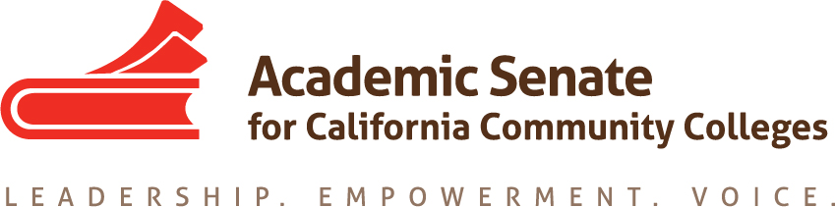

Accreditation and Assessment Committee

Monday October 24th, 2016

4:30 PM – 6:00 PM

https://cccconfer.zoom.us/j/3285687631

Or iPhone one-tap (US Toll): 14086380968,3285687631# or 16465588656,3285687631#

Or Telephone:

Dial: +1 408 638 0968 (US Toll) or +1 646 558 8656 (US Toll)

Meeting ID: 328 568 7631

- Order of the Agenda
- Approval of Minutes from September 24th, 2016
- Revised Committee Charge (Action)
- Update on ASCCC Executive Committee to NACIQI about ACCJC (discussion)
- Update CEO Accreditation Workgroups (discussion)
- Warren Bill on Accreditation and ACCJC Analysis (discussion)
- Review of Draft Accreditation Institution Program (discussion)
- ACCJC Participation at Accreditation Institute (discussion)
- Other

