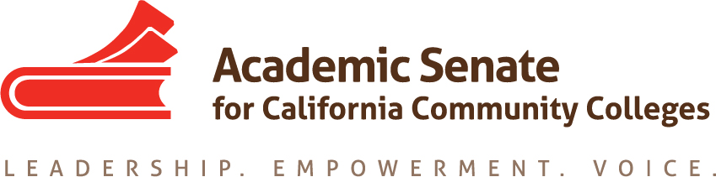

Accreditation Committee

Wednesday December 14th, 2016

4:30 PM – 6:00 PM

https://cccconfer.zoom.us/j/3285687631

Or iPhone one-tap (US Toll): +16465588656,3285687631# or +14086380968,3285687631#

Or Telephone:

Dial: +1 646 558 8656 (US Toll) or +1 408 638 0968 (US Toll)

Meeting ID: 328 568 7631

- Order of the Agenda
- Approval of Minutes from October 24, 2016
- Review Approved Committee Charge (discussion)

Accreditation Committee

The Accreditation Committee advises the Executive Committee and the faculty in matters related to accreditation and continuous quality improvement. The committee identifies and disseminates knowledge and information regarding faculty roles and effective practices in conducting comprehensive college-wide assessment, meeting and documenting accountability standards, self-evaluation methods and reports, attaining and maintaining accreditation status, and in supporting faculty as they reflect on outcomes and set goals for improvement. The committee receives input from, and collaborates with, pertinent outside groups including regional accreditors and federal agencies, their policies, and processes. Under the direction of the President, designated committee members assist faculty and local academic senates with matters related to accreditation. The committee also plans the annual Accreditation Institute that offers professional development on accreditation issues, policies, and best practices.

- Report out from Fall Plenary Session (discussion)
- Accreditation Committee Rostrum Articles(discussion)
- Review Accreditation Institution Program (discussion)
- Accreditation Institute Evaluation Survey (discussion)
- Other

