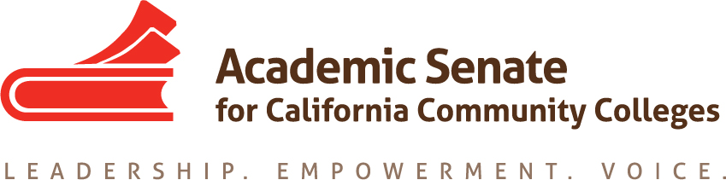

Accreditation Committee
November 14, 2017
4:00 pm – 5:00 pm
CCC Confer
Dial your telephone conference line: 1-913-312-3202*
Presenter Passcode: 1285317
Participant Passcode: 447949
*Toll free number available: 1-888-886-3951

MINUTES

Members Present: Ginni May, John Freitas, Misty Burruel, Irit Gat, Christy Karau-Magnani, Deborah Wulff

Members Absent:

Guests: Steven Reynolds

- Select note taker – Misty Burruel

- Approval of Agenda – Approved by email

- Approval of minutes – Approved by email

- Announcements –

  - 2017 Fall Session took place and resolutions are now available for reference
  - Final Resolutions Adopted November 4, 2017

- Preparation for November 18 Meeting at Los Angeles City College – Committee decided to begin this meeting at 10 am to accommodate travel time. John will email the committee his cell number and building location for this meeting. Committee members are advised to park in Lot 4 on Heliotrope under the athletic field. Committee will grab lunch across the street.
  - Most recent version of the Accreditation Institute Program
    - Draft is available online: 2018 Accreditation Institute
    - Draft may change based on additional feedback
  - Draft Breakout Facilitators, Titles, Descriptions, Presenters
    - General Session 3: The Compton College Story – Individuals have been identified to present
    - VPs will do a General Session
    - Committee is encouraged to review the 2018 Accreditation Institute program draft in preparation for Saturday’s meeting and consider the titles, descriptions, and who the presenters will be and bring recommendations. Committee should also take a look at the 2017 program for comparison: 2017 Accreditation Institute. Any presenter recommendations will need be finalized by Julie Bruno, President of ASCCC.
    - Communication to the field: The committee will draft a message at Saturday’s meeting that can be sent to the field reminding them to register for the Accreditation Institute.
    - Ginni will submit Irit, Christy, and Misty’s names for the Accreditation Institute. Committee members will be reimbursed for mileage. ASCCC will take care of hotel accommodations.

- Upcoming Events (http://asccc.org/calendar/list/events)

- Future Meetings
November 18, 2017, 10:00 am – 3:00 pm, Los Angeles City College
November 28, 2017, 4:00 pm, CCC Confer
December 12, 2017, 4:00 pm, CCC Confer

- Adjourn

Status of Previous Action Items

- In Progress (include details about pending items such as resolutions, papers, Rostrums, etc.)

ASCCC Resolutions

S15 2.01 Disaggregation of Learning Outcomes Data
Research has been completed and presented at the ACCJC Conference in April 2017 and Spring 2017 Plenary Session. An annotated bibliography was provided to the Academic Senate and the ASCCC Foundation as part of the SLO Disaggregation project funded by the Foundation. 2017 - 18: Research was presented at the ACCJC 2017 Partners in Excellence Conference. Committee will hold off on I.B.6 until we hear back from ACCJC in January 2018. There could be a Rostrum to give an update on Disaggregation of Learning Outcomes Training, 2.01.

S15 2.02 ACCJC Written Reports to Colleges on Sanction
2017 - 18: The CCCCO Workgroups 1 and 2 have been involved in recommending many changes. An update will be presented at the Accreditation Institute.

F16 2.01 Local Recruitment and Nomination Processes for Accreditation Teams
2017 - 18: There will be a New Evaluator Training for Faculty at the Accreditation Institute Pre-session. In addition, a Rostrum article will be written to address the processes following the Accreditation Institute.

S17 9.01 Update to the Existing SLO Terminology Glossary and Creation of a Paper on Student Learning Outcomes
2017 - 18: The Chairs of the Curriculum and the Accreditation Committees are in the process of identifying committee members to serve on a task force to update the SLO Glossary and create a paper on Effective Practices for Student Learning Outcomes Assessment. Christy volunteered to serve on this task force but the group has not been organized.

Strong Workforce Recommendations
Timeline | Goal | Current Positions | Action | ASCCC Committee Involvement |  | Comments
TBD | 9. a. Engage employers, workforce boards, economic development entities, and other workforce organizations with faculty in the program development and review process | 7.05 S14 Research Tools for Program Review; 13.02 F12 Redefinition of Student Success;  21.02 S12 CTE Program Review | Co-develop | CTE LC AAC Curriculum (EDAC) | High | 2017 - 18: Committees chairs to recommend to the president how to implement this recommendation. Resolution 21.02 S12 should be part of this conversation.
TBD | 9. b . Promote effective practices for program improvement (retooling) and program discontinuance based upon labor market data, student outcomes and input from students, faculty, college staff, employers, and workforce partners. |  | Develop | Ed Pol, AAC, and Curriculum | High | 2017 - 18: Ed. Policies to lead the conversation. Committee chairs to recommend to the president how to implement this recommendation. Chairs might consider exploring the development of a PDC Module using the ASCCC paper on program discontinuance. The Ed Pol might also be able to touch on some of recommendation in the upcoming on Educational Program Development.

Committee was asked to consider the Strong Workforce outline for discussion during Saturday’s meeting. John raised concerns that this may or may not be the Accreditation Committee’s responsibility and consider recommending that the resolution be reassigned to another committee.

Papers/Rostrums

- S17 9.01
- F16 2.01

- Completed (include a list of those items that have been completed as a way to build the end of year report).

