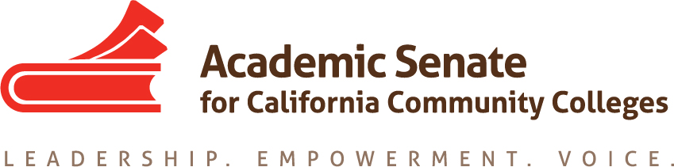

Accreditation Committee
August 17, 2017
8:15 am
(update phone call at 4:00 pm for those unable to make 8:15 call)
CCC Confer
Dial your telephone conference line: 1-913-312-3202*
Presenter Passcode: 6874826 (at 4:00 pm: 3624084)
Participant Passcode: 484885 (at 4:00 pm: 802556)
*Toll free number available: 1-888-886-3951

MINUTES

Members Present: Ginni May (chair), John Freitas, Misty Burruel, Christy Karau

Members Absent: Debbie Laffranchini, Deborah Wulff, Irat Gat

Guests:

- Select note taker— John Freitas.

- Approval of Agenda - approved

- Approval of minutes – no minutes to approve

- Overview of Accreditation Committee and expectations of committee work this year
The Committee Charge is as follows:
The Accreditation Committee advises the Academic Senate Executive Committee and the faculty regarding accreditation and continuous quality improvement. The committee identifies and disseminates knowledge and information regarding faculty roles and effective practices in conducting comprehensive college-wide assessment, meeting and documenting accountability standards, self-evaluation methods and reports, attaining and maintaining accreditation status, and in supporting faculty as they reflect on outcomes and set goals for improvement. The committee receives input from, and collaborates with, pertinent outside groups including regional accreditors and federal agencies, their policies, and processes. Under the direction of the president, designated committee assist faculty and local academic senates with matters related to accreditation and institutional evaluation. The committee also plans the annual Accreditation Institute that offers professional development on accreditation issues, policies, and effective practices.
More information about the committee can be found at http://asccc.org/directory/accreditation-committee-0.

The committee charge was noted and members were encouraged to review it and the committee web page. Ginni stated that she planned to have at least one phone meeting per month, but no more than two meetings per month, leading up to the institute. Committee members will either be breakout presenters or breakout facilitators. Ginni also noted the resolutions assigned to the committee (see bottom of agenda) and asked that committee members review them before the September 16 meeting. Ideas for addressing the resolutions will be discussed at that meeting.

The Accreditation Committee will work with the Curriculum Committee on an SLO paper via a special task force. Committee members may volunteer for it.

Accreditation Institute:
February 23-24, 2018 (Pre-session February 22), Wyndam Anaheim, Garden Grove
http://asccc.org/events/2018-02-23-160000-2018-02-24-230000/2018-accreditation-institute

The committee’s responsibility for planning the Accreditation Institute was noted and the membership was informed that the cost of committee member attendance is covered by the ASCCC. It is expected that the AI program should be developed by the end of September.
The pre-session was briefly described. There will be a training for faculty on visiting teams, and training for ALOs. The limit for the faculty session is 60.
Ideas for institute strands/breakout sessions:
- Other types of accreditation (programmatic accreditors, WASC schools and noncredit, relationship of programmatic accreditation and senate engagement).
- The Four Standards
- Changes on the Horizon/What does the future hold?
- Multi-college districts
- Quality Focus Essay and faculty role, relation to institutional planning, sustaining the momentum of the QFE
If there are any other ideas, send them to Ginni.

- Breakout Topics for Fall Plenary Session
Breakout topic ideas are due by August 21. Please send ideas for topics to Ginni before then.

- Resolution Ideas for Fall Plenary Session
Pre-session resolutions are due by September 12. Please send ideas to Ginni before then.

- Upcoming Events (http://asccc.org/calendar/list/events)
Area Meetings: October 13-14, 2017
Fall Plenary Session: November 2-4, 2017, Irvine Marriott
Upcoming events were announced. For additional information go to http://asccc.org/calendar/list/events.

- Future Meetings
September 16, 2017 – Chaffey College, 11:30-3:45 (http://asccc.org/resources/forms)
Ginni noted the flight times to and from Sacramento. The meeting will include a working lunch. A lunch menu will be sent out and committee members to send in lunch selections to Misty by September 14 at 12:00.

- Adjourn – adjourned at 9:07 am.

Status of Previous Action Items

- In Progress (include details about pending items such as resolutions, papers, Rostrums, etc.)

ASCCC Resolutions

S15 2.01 Disaggregation of Learning Outcomes Data
Research has been completed and presented at the ACCJC Conference in April 2017 and Spring 2017 Plenary Session. An annotated bibliography was provided to the Academic Senate and the ASCCC Foundation as part of the SLO Disaggregation project funded by the Foundation. 2017 - 18: The Committee will discuss next steps for the use of the research information.

S15 2.02 ACCJC Written Reports to Colleges on Sanction
2017 - 18: The committee to consider how best to respond to this resolution.

F16 2.01 Local Recruitment and Nomination Processes for Accreditation Teams
2017 - 18: The committee chair to discuss with the president how best to accomplish this resolution.

S17 9.01 Update to the Existing SLO Terminology Glossary and Creation of a Paper on Student Learning Outcomes
2017 - 18: The Chairs of the Curriculum and the Accreditation Committees will identify committee members to sit on a task force to accomplish this resolution.

Papers/Rostrums

- S17 9.01

- Completed (include a list of those items that have been completed as a way to build the end of year report).

