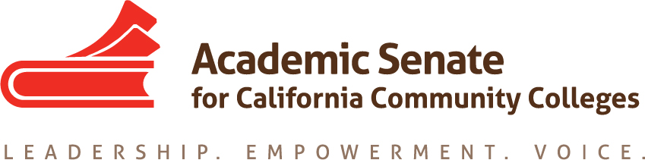

ASCCC Accreditation Committee

October 15, 2019

10:00am-3:00pm

ASCCC Offices One Capitol Mall, Suite 230, Sacramento, CA 95814;

Or CONFERENCE CALL INFORMATION

Phone one-tap: | US: +16699006833,,378274381# or +16468769923,,378274381#
Meeting URL: | https://cccconfer.zoom.us/j/378274381
Meeting ID: | 378 274 381

AGENDA

- Call to Order and Adoption of the Agenda

- Selection of Minutes Taker and approval of last meetings Minutes

- Meeting Logistics

- Action Items
  - Assigned Tasks
    - Discussion with Stephanie Droker, ACCJC Executive Vice President regarding Institute
    - Identify Institute General Session Topics
    - Identify Institute Breakouts
    - Identify Potential Speakers
    - Create Draft Institute Program

- Accreditation Institute Logistics (February 21-22, 2019)
  - Travel
  - Registration –Code for Registration
  - Location: San Diego Marriott—La Jolla
  - Need for an additional in person meeting in January?

- Potential Rostrum Articles/Resolutions

- Important Dates
  - Fall Plenary Session (November 7-9, 2019)
  - 2020 Part Time Faculty Institute (January 24-25, 2020)
  - 2020 Accreditation Institute (February 21-22, 2020)

- Next Meeting Date

- Adjournment

