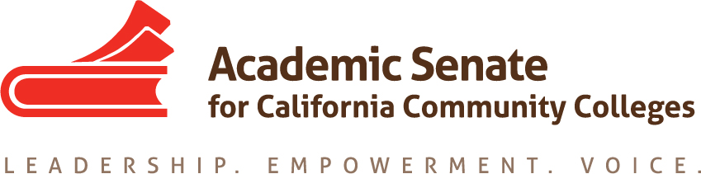

ASCCC Accreditation Committee

November 12, 2019

9:00am-11:00am

ZOOM
Phone one-tap: | US: +16699006833,,185084081# or +16468769923,,185084081#
Meeting URL: | https://cccconfer.zoom.us/j/185084081
Meeting ID: | 185 084 081

AGENDA

- Call to Order and Adoption of the Agenda

- Selection of Minutes Taker and approval of last meetings Minutes

- Update on ASCCC Executive Committee review of and input on the initial draft agenda for 2020 Accreditation Institute

- Action Items
  - Assigned Tasks
    - Address any Exec Committee changes or concerns
    - Discuss General Sessions
    - Identify Institute Breakout Presenters
    - Discuss Breakout Descriptions
    - Discuss Welcome Letter for Institute
    - Create Second Draft Institute Program
    - Create Timeline for Breakout Descriptions and final Presenters List

- Accreditation Institute Logistics (February 21-22, 2019)
  - Travel
  - Registration –Code for Registration
  - Location: San Diego Marriott—La Jolla

- Potential Rostrum Articles/Resolutions

- Important Dates
  - 2020 Part Time Faculty Institute (January 24-25, 2020)
  - 2020 Accreditation Institute (February 21-22, 2020)

- Next Meeting Date

- Adjournment

