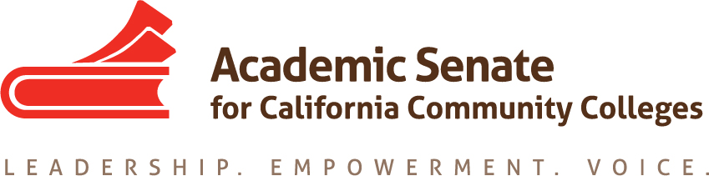

ASCCC Accreditation Committee

February 12, 2020

1:00-2:00pm

ZOOM

Join Zoom Meeting
Phone one-tap: | US: +16699006833,,814613810# or +16468769923,,814613810#
Meeting URL: | https://cccconfer.zoom.us/j/814613810
Meeting ID: | 814 613 810

AGENDA

- Call to Order and Adoption of the Agenda

- Selection of Minutes Taker and approval of last meetings minutes

- Check in on Progress for Accreditation Institute

- Institute Logistics

- Potential Rostrum Articles/Resolutions

- Important Dates
  - 2020 Accreditation Institute (February 21-22, 2020)

- Next Meeting Date

- Adjournment

