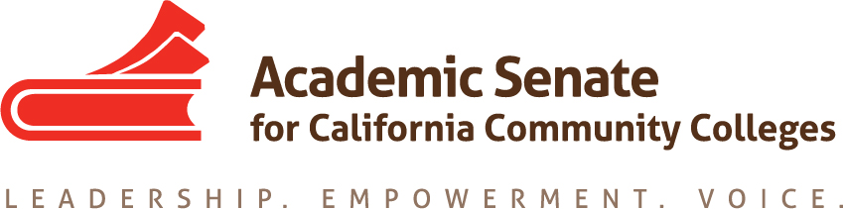

ASCCC Accreditation Committee

September 24, 2019

11:00am-12:00pm

CONFERENCE CALL INFORMATION
Phone one-tap: | US: +16699006833,,977216302# or +16468769923,,977216302#
Meeting URL: | https://cccconfer.zoom.us/j/977216302
Dial: | US: +1 669 900 6833 or +1 646 876 9923
Meeting ID: | 977 216 302

AGENDA

- Call to Order and Adoption of the Agenda

- Selection of Minutes Taker

- In Person Meeting Logistics

- Action Items
  - Assigned Tasks
    - Planning for In Person Meeting
    - Brainstorming Institute General Sessions
    - Brainstorming Institute Breakouts
    - Other

- Accreditation Institute Logistics (February 21-22, 2019)
  - Travel
  - Registration –Code for Registration
  - Pre-Session Training
  - Location: San Diego Marriott—La Jolla

- Potential Rostrum Articles

- Important Dates
  - Academic Academy (September 13-14, 2019)
  - Area Meetings October 11 and 12, 2019)
  - Fall Plenary Session (November 7-9, 2019)
  - 2020 Part Time Faculty Institute (January 24-25, 2020)
  - 2020 Accreditation Institute (February 21-22, 2020)

- Next Meeting Dates

- Adjournment

