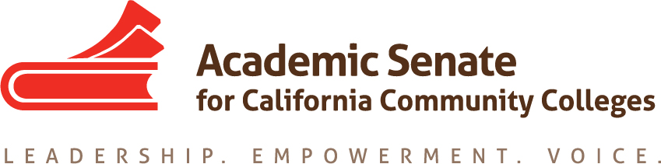

ASCCC Accreditation Committee

January 24, 2020

1:00-3:00pm

ZOOM

Attendees: Stephanie Curry, Nate Donahue, Elizabeth Romero, Sheri Berger, Ted Blake, Ekaterina Fuchs, Roy Shahbazian

Minutes

- Call to Order and Adoption of the Agenda

The meeting was called to order at 1:02pm. The committee adopted the agenda.

- Selection of Minutes Taker and approval of last meetings minutes

Stephanie will take minutes and the committee was sent the meeting minutes from the 12/16/19 meeting. Committee members were asked to review the minutes and send any changes to Stephanie

- Check in on Progress for Accreditation Institute

Each member of the committee gave an update on their progress in facilitating their assigned breakouts.

Committee members reviewed the final draft of the program and the welcome letter.

Stephanie will send the final program, welcome letter and list of speakers to Krystinne Mica at ASCCC

- Institute Logistics

Committee agreed to meet for dinner on Thursday night before the Institute

- Potential Rostrum Articles/Resolutions

At the institute committee members will see if there are any emerging issues that may require resolutions for the Spring Plenary

- Important Dates

  - PPTs for uploading to website and app goal (February 14, 2020)
  - 2020 Accreditation Institute (February 21-22, 2020)

- Next Meeting Date

The committee agreed to meet again the week of February 10th.

- Adjournment

The meeting adjourned at 1:40pm

