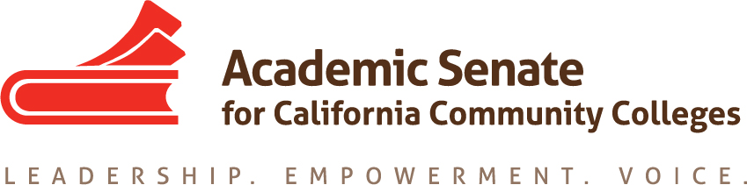

ASCCC Accreditation Committee

April 29, 2020

10:00-11:00pm

ZOOM

Attendees: Stephanie Curry, Nate Donahue, Elizabeth Romero, Sheri Berger, Ekaterina Fuchs, Ted Blake, Roy Shahbazian

Minutes

- Call to Order and Adoption of the Agenda

The committee reviewed the agenda, no changes were made

- Selection of Minutes Taker and approval of last meetings minutes

Stephanie Curry will take minutes

- Wellness Check in

Committee members each did a wellness check-in and discussed coping techniques used to address stress during the COVID-19 crisis

- 2020 Accreditation Institute debrief/ Review of survey

Committee discussed what worked well and what could be improved for future accreditation Institutes and discussed a review of the participant survey.
- Overall good institute, lots of participant engagement
- Theme of Accreditation, Equity and Guided Pathways very effective. Attendees liked the idea of using things we are already doing to address accreditation standards. “Ah Ha” moments for attendees on connections between Accreditation, Equity and Guided Pathways
- Special shout out to Panel by Grossmont College on Equity very effective and participants liked the practical application of equity work
- Some sessions were surprisingly popular such as the Enrollment Management/Scheduling breakout
- Set a good tone for relationship between California Community Colleges and ACCJC
- People liked the opportunities to share stories of what was happening at their campus and interacting and brainstorming with each other (crowdsourcing ideas)
What we learned/recommendations for future institutes
- Keep presenters limited to experts on the topics even it its just one or two people
- More best practices options. Attendees were hungry for examples specifically as it relates to Guided Pathways
- Perhaps limit types of presentation to 2 types rather than 3 (Collaborative/Informational). The interactive was harder to define.
- Balance out intro to accreditation and application of standards in breakouts. Survey mentioned that some were looking for Accreditation 101 presentations

- Some Standard III presentations less attended so perhaps combine those rather than independent breakouts
- Do more presentations on DE (especially with COVID-19 crisis impact) include practical example of examples/innovations being done to support students and student learning including new definitions, policies and innovative practices
- Many attendees liked the conference app. Recommend having both paper and online app for events until attendees get used to the app. Some issues with the app not being up to date or consistent with what was in the paper agenda such as the reception.

- Potential Rostrum Articles/Resolutions

None at this time

- Committee wrap up/ Recommendations for next years committee

Committee discussed some potential areas for the 2020-2021 ASCCC Accreditation Committee
- Continue the discussion on Accreditation in a time of Emergency and provide support to colleges
- Get feedback from the colleges in the new Summative/Comprehensive visits pilot and share that information with the field
- Proactively work with ACCJC to identify the role of faculty/senates in future standards revisions

Committee Chair Stephanie Curry thanked the committee for all their hard work this year and the stellar job done on the 2020 Accreditation Institute.

- Adjournment

The committee adjourned at 10:56am

