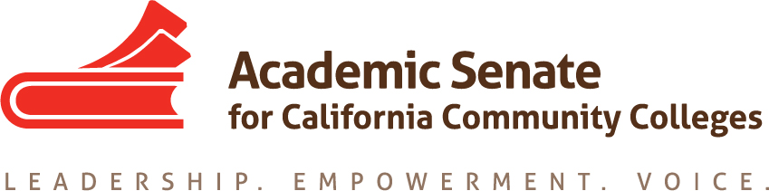

ASCCC Accreditation Committee

September 24, 2019

11:00am-12:00pm

Minutes

Attendees: Stephanie Curry, Liz Romero and Ekaterina Fuchs

- Call to Order and Adoption of the Agenda

Meeting was called to order at 11:00am

- Selection of Minutes Taker

Stephanie will take minutes

- In Person Meeting Logistics

Logistics and travel arrangements for the October 15th meeting in Sacramento were discussed. Stephanie will send out lunch menu for everyone to review and provide for pre-order.

- Action Items
  - Assigned Tasks
    - Planning for In Person Meeting

Committee planned for the in-person meeting including goals for the day, which included a draft schedule of the Institute and identification of potential speakers for ASCCC Exec approval at the November Meeting

    - Brainstorming Institute General Sessions

The group decided to hold off on this discussion until ASCCC Exec Committee approves the theme

    - Brainstorming Institute Breakouts
The group reviewed the list of potential breakouts and added additional suggestions including identifying the types of breakouts (informative, interactive, and collaborative) based on feedback from previous ASCCC institutes

- Accreditation Institute Logistics (February 21-22, 2019)

Logistics were discussed including the need for committee members to register for the event through the ASCCC webpage. Contact Stephanie or Nate for the code for committee members to register.

- Important Dates

Important dates for the ASCCC were posted as a reminder.

  - Area Meetings October 11 and 12, 2019)
  - Fall Plenary Session (November 7-9, 2019)
  - 2020 Part Time Faculty Institute (January 24-25, 2020)
  - 2020 Accreditation Institute (February 21-22, 2020)

- Next Meeting Dates

The Committees next meeting will be October 15, 2019 in Sacramento (ASCCC Offices)

- Adjournment

The meeting adjourned at 11:30am

