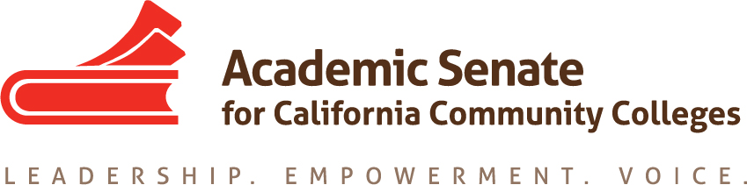

Equity and Diversity Action Committee
October 7, 2020
11:30 am-12:30 pm

ConferZoom

MINUTES

Members Present: LaTonya Parker (chair), Ginni May (2nd), Peggy Campo, Abdimalik Buul, Jamar London, LaTanga Hardy

- Call to Order at 11:33 am

- Approval of Agenda: M/S/P – Peggy/LaTanga

- Check-in: Committee members checked-in and shared a highlight about their current lives.

- Committee Responsibilities: The committee chair reminded the committee of the priorities and scope of work for EDAC this fall:

- ASCCC Areas of Focus for 2020-21
- Guided Pathways Implementation and Integration to Transfer and Careers
- Culturally Responsive Student Services, Student Support, and Curriculum;
- Equity Driven Systems

- From the Chancellor’s Office Diversity, Equity, and Inclusion (DEI) Workgroup:
- ASCCC, HR, and local union to review existing evaluation procedures. (Tier 1)*
- ASCCC, HR, and local union to create a process where conversations about cultural competencies can happen outside the evaluation process. (Tier 1)*

*Tier 1 and Tier 2 activities are strategies that involve policy changes, changes to existing procedures, and or activities that promote supportive and inclusive behaviors. Aligned to the Vision for Success commitments, Tier 1 activities can be achieved in a 6-12 months’ timeline (CCCCO Call for Action June 2020)

The committee was reminded of the discussion during last month’s meeting:

- Ways to examine and modify review processes, procedures, and structures.

- Topics around accountability, explicit training, measurable outcomes, onboarding, eradicating systemic injustices, creating equity minded syllabi, inquire/interrogate/integrate, mentoring, and clarity about what faculty are being assessed on.

- ASCCC, HR, and local union to review existing evaluation procedures.

- Recommendations:
  - Faculty evaluation should be two-sided with a growth focus as opposed to a punitive focus and one of checking boxes.
  - Academic senate and union representatives need to work together and have some power to make recommendations for real change.
  - ASCCC, HR, and local union to create a process where conversations about cultural competencies can happen outside the evaluation process.
  - Mentor program: although there were concerns that it could be a burden on the few faculty that understand how to create a culturally competent learning environment.
  - Toolkit for creating equity-minded syllabus with a repository of examples
  - Discipline specific webinars for creating a culturally competent environment

- The committee discussed the recommendations that could be prioritized in order to begin to address? Prioritized work is in bold font.
  - The Toolkit
  - Webinars – discipline specific near spring FLEX days for faculty professional development
  - EDAC will work with GPTF
  - Some homework will be assigned during the November meeting to bring ideas for the webinars and planning at the December meeting.
  - Mentor program – provide a recommendation to the FELA; Could come out of the panel Q&A from the webinars from those that interested in following up, and especially discipline specific; Peggy volunteered to research some mentor models and bring some resources to the December meeting

- Fall Plenary
Sessions assigned to the committee chair were shared, and committee members were invited to join one of the sessions.

- Regional Meetings – Updates regarding partnerships with ASCCC Guided Pathways Task Force. Ginni briefly shared some of the proposed plans of the GPTF for integrating GP work into the ASCCC Standing Committees. More information will be provided during the November meeting.

- Rostrum Article(s) – articles for consideration are due in January. Bring ideas to the November meeting. One idea shared was “Getting to the why”.

- Resolutions

  - https://www.asccc.org/resolutions-fall-2020
  - The committee chair shared two proposed resolutions regarding an ethnic studies requirement.

- Action Item: Tier 1 Recommendations

  - ASCCC, HR, and local union to review existing evaluation procedures.
  - ASCCC, HR, and local union to create a process where conversations about cultural competencies can happen outside the evaluation process.

- Resources:
Resource 1—Equity and Diversity Action Committee Resolutions Report Dec 2019 Revisions
Resource 2— THE ACADEMIC SENATE FOR CALIFORNIA COMMUNITY COLLEGE ADOPTED FALL 2019 EQUITY-DRIVEN SYSTEMS Student Equity and Achievement in the California Community Colleges
Resource 3— Summer 2020 ASCCC Rostrum
Resource 4—II. E. (1) EDAC Charge, ASCCC Inclusivity Statement Revise.pdf
Resource 5—II. E. (2) EDAC ACTION PLAN draft.pdf
Resource 6— https://www.asccc.org/directory/equity-and-diversity-action-committee

- Fall 2020 Committee Meeting Dates were agreed on by all committee members.
- Wednesday, November 18, 2020 11:30-12:30
- Wednesday, December 2, 2020 11:00-2:00 – this meeting time was extended.

- Forms (when travel resumes):
ASCCC Flight and Travel Request Link
ASCCC 2020 Expense Reimbursement Form

- Upcoming Events – ASCCC and system-wide events were shared.

- Announcements – none

- Adjourned Meeting at 12: 28pm

