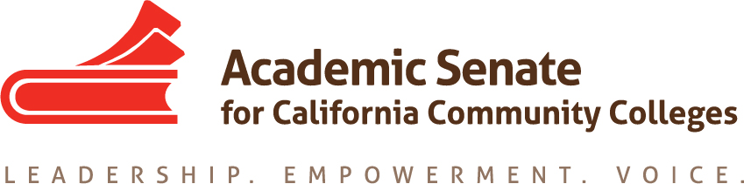

Equity and Diversity Action Committee
September 2, 2020
1:30 pm-3:00 pm

ConferZoom

MINUTES

Members Present: LaTonya Parker (chair), Ginni May (2nd), Peggy Campo, Abdimalik Buul, Jamar London, LaTanga Hardy

- Call to Order at 1:33 pm

- Approval of Agenda: M/S/P – Campo/London

- Check-in: Committee members introduced themselves and shared the areas in which they work.

- Committee Responsibilities: The committee chaired outlined the priorities and scope of work for EDAC this fall. In particular the following were highlighted:

- ASCCC Areas of Focus for 2020-21
- Guided Pathways Implementation and Integration to Transfer and Careers
- Culturally Responsive Student Services, Student Support, and Curriculum;
- Equity Driven Systems

- From the Chancellor’s Office Diversity, Equity, and Inclusion (DEI) Workgroup:
- ASCCC, HR, and local union to review existing evaluation procedures. (Tier 1)*
- ASCCC, HR, and local union to create a process where conversations about cultural competencies can happen outside the evaluation process. (Tier 1)*

*Tier 1 and Tier 2 activities are strategies that involve policy changes, changes to existing procedures, and or activities that promote supportive and inclusive behaviors. Aligned to the Vision for Success commitments, Tier 1 activities can be achieved in a 6-12 months’ timeline (CCCCO Call for Action June 2020)

- Fall Plenary
The committee chair submitted proposed breakout topics on August 13, 2020 for consideration by the ASCCC President and Executive Director.
- Anti-Racism Professional Development
- Active Anti-Racism Leadership Development
- Culturally Reflective Pedagogy and Student Services
- Anti-Racism and Transforming Institutional Policies and Practices

- Regional Meetings – The ASCCC Guided Pathways Task Force (GPTF) has offered to partner with EDAC if EDAC opts to provide regional meetings this fall. One of the continuing overarching goals of the GPTF is to “amplify equity work”.
- Rostrum Article (s) – committee members were invited to submit a Rostrum article if desired. The due date for the first Rostrum is September 25.
- Resolutions – https://asccc.org/resources/resolutions
The committee chair discussed passed resolutions by EDAC and how the resolutions are being addressed.
- 3.02 (Anti-Racism Paper) and
- 10.02 (Minimum Qualifications) Action Taken
In addition, the ASCCC resolution process was detailed.

- Action Item: Tier 1 Recommendations

- ASCCC, HR, and local union to review existing evaluation procedures.
Committee members discussed ways to examine and modify review processes, procedures, and structures. Discussion included topics around accountability, explicit training, measurable outcomes, onboarding, tenure process, eradicating systemic injustices, creating equity minded syllabi, inquire/interrogate/integrate, mentoring, clarity about what faculty are being assessed on.
Possible recommendations:
- Faculty evaluation should be two-sided with a growth focus as opposed to a punitive focus and one of checking boxes.
- Academic senate and union representatives need to work together and have some power to make recommendations for real change.
- Improvement of Instruction assessment of meaningful areas to include, but not limited to the following:
  - Cultural competencies in the classroom
  - Identify what is missing
  - Identify what is needed
  - Holistic analysis
  - Autonomy
  - Accountability
  - Tangible

- ASCCC, HR, and local union to create a process where conversations about cultural competencies can happen outside the evaluation process.
Committee members shared ideas. Possible recommendations:
- Mentor program: although there were concerns that it could be a burden on the few faculty that understand how to create a culturally competent learning environment.
- Toolkit for creating equity-minded syllabus with a repository of examples
- Discipline specific webinars for creating a culturally competent environment
- Toolkit (i.e. resource on eradicating systemic racism)
- Mandatory equity minded syllabus training
- Trained evaluators
- Collaborations with bargaining units
- Task Force / Committee under local senate with the authority to carry out the ongoing work
- Communities of practice
  - Remote Academic
  - Rate Matters Model (i.e. Integration of self, self and others and Systems.)

- Resources – The committee chair explained about the ASCCC and EDAC resources and where to find them.

- Fall 2020 Committee Meeting Dates were agreed on by all committee members.
- Wednesday, October 7, 2020 11:30-12:30
- Wednesday, November 18, 2020 11:30-12:30
- Wednesday, December 2, 2020 11:30-12:30

- Forms – Travel reimbursement forms were discussed in case travel should resume.

- Upcoming Events – ASCCC and system-wide events were shared.

- Announcements – no announcements

- Adjourned Meeting at 2:44 pm

