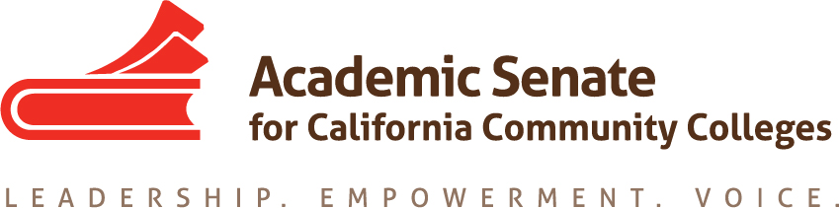

Educational Policies Committee
November 9, 2016
3:00 pm – 4:00 pm

CCC Confer
Dial your telephone conference line: 1-913-312-3202*
Presenter Passcode: 9792445
Participant Passcode: 835850
*Toll free number available: 1-888-886-3951

MINUTES

Members Present: Ginni May, Randy Beach, Donna Greene, Catherine McKay, Michael Flores, Andrea Devitt, Saleem Moinuddin, Lillian Batista-Edwards

- Select note taker – G. May

- Approval of Agenda – approved by consensus

- Approval of minutes – done by email

- Paper Outline – Effective Practices for Educational Program Development
  - Finalized Outline based on recommendations from ASCCC Executive Committee
  - Assigned sections for initial writing of draft
  - Confirmed timeline to complete paper:
- Final Draft to Exec February 24
- First Draft to Exec January 27
- First rough draft for discussion January 11
- Section drafts due to G. May December 16
Section drafts will be written in a word document using Times New Roman, 12 font, 1-inch
margins, single space and no other formatting—If writers fall behind schedule, let G. May know
immediately so that these sections can be completed on time.

- AB 1985 Overview – G. May went over the requirements of AB 1985 and shared the draft survey to go out to the senate body regarding creating a state wide policy on awarding General Education credit for those that receive passing scores on College Board Advanced Placement Exams. The California Community Colleges Chancellor’s Office is to work with the Academic Senate for California Community Colleges to create a uniform policy for the California Community Colleges in awarding AP credit for GE courses to be in place by fall 2017. If such a policy is not created, then the California Community Colleges are to use the same policy that is used by the California State University.

- Future Meetings:
- Wednesday, December 14, 3:00-4:00 – CCC Confer
- Wednesday, January 11, ~10:30-3:30 – Sacramento
- Wednesday, February 22, 3:00 pm-4:00 pm – CCC Confer
- Wednesday, March 22, 3:00 pm-4:00 pm – CCC Confer
- In person March 11--If needed
- Wednesday, April 12, 3:00 pm-4:00 pm – CCC Confer

- Future ASCCC Events (not all events are listed):
- ASCCC Area A, B Meetings, March 24
- ASCCC Area C, D Meetings, March 25
- ASCCC 2017 Spring Plenary Session, April 20-22, San Mateo
- ASCCC 2017 CTE Leadership Institute, May 5-6, San Jose
- ASCCC Faculty Leadership Institute, June 15-17, Sacramento
- ASCCC Curriculum Institute, July 12-15, Riverside
- ASCCC Events

