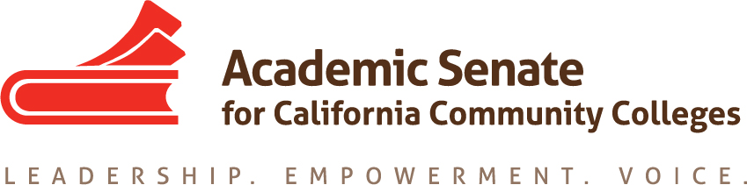

Educational Policies Committee
March 20, 2017
3:00 pm – 4:00 pm

CCC Confer
1-913-312-3202 OR 1-888-886-3951
Presenter Passcode: 6755634
Participant Passcode: 928127

MINUTES

Members Present: Ginni May, Randy Beach, Donna Greene, Michael Flores, Andrea Devitt, Saleem Moinuddin

- Select note taker – Ginni

- Approval of Agenda – Done

- Approval/Review of minutes – Done

- Paper – Effective Practices for Educational Program Development
The committee recommended that the work done this year be compiled and provided to next year’s committee to complete the work. Currently, there are four committee members working on the paper, and more contributers are needed. Committee members could not guarantee that they could work over the summer off contract, but will be available in the fall to follow up with the next committee. Once member is interested in serving on this committee again next year. Ginni is checking with ASCCC Leadership for direction.

- AB 1985 Survey and Policy for AP Examination Course Credit in the California Community Colleges
Update: Final policy language should be sent out from the CCCCO by the end of this week or next week.

- Dual Enrollment – Donna Greene
There is nothing new to report since the bulk of this work has been done. At this point, the loose ends are being tied and sharing of the work will be done at the spring 2017 plenary session

- Update on Rostrum Article: Revisit plan from January 11, February 8
Jan Plan: By February 4, Randy, Michael and Donna will send in paragraphs for a rostrum article that highlights current effective practices for integrating industry professionals into CTE instruction such as faculty internships where needed, guest lecturing, and supplemental teaching partnerships with non-faculty. Anticipate submitting for March/April 2017 edition of the Rostrum.
Feb Plan: We will push this article to the May rostrum.
March Plan: Donna and Dre will work with the draft of Michael to send Ginni a draft by April 27/28. From there Ginni will polish it a bit and send it off for the next Rostrum. This article will have just the author’s names, not the entire committee.

- Plenary Session: April 20-22 at the San Mateo Marriott
  - Breakouts:
Second Breakout Session 2:00 pm-3:15 pm

- Educational Program Development, AB 1985, and the QRTF—What are they, what has been done, and what’s next?
Participants will be updated about the latest work of the ASCCC Educational Policies Committee and have an opportunity to join their colleagues in an informed discussion on what lies ahead. Topics will include: the state of the Paper on Effective Practices for Educational Program Development (Resolution 9.02 Spring 2016); Advanced Placement Examination General Education Credit Policy (AB 1985); and the Academic Senate of the California State University Quantitative Reasoning Task Force Report and Recommendations (Resolution 15.01 Fall 2016).

Randy Beach, ASCCC South Representative
Ginni May, ASCCC North Representative

Fourth Breakout Session 2:15 pm – 3:30 pm

- The Institutional Effectiveness Partnership Initiative (IEPI) and You!
The Institutional Effectiveness Partnership Initiative (IEPI) is now in its third year of existence, and much work has been done. Participants will receive a brief overview of the IEPI, details on the Professional Learning Network (PLN) and the Applied Solution Kits (ASKs), and information on how faculty can and should be involved.

Ginni May, ASCCC North Representative
Wheeler North, Mira Costa College
Michelle Pilati, Rio Hondo College

Breakout Session ?

0. Dual Enrollment (Davison/Greene)
With the passage of AB288 (Holden, 2015) and subsequent legislation, many colleges became interested in expanding upon their dual enrollment offerings. While this was occurring, several groups, including the ASCCC and the Chancellor’s Office, participated in workgroups designed to create effective practices and work with colleges to assist in developing dual enrollment opportunities. This breakout will update participants on the status of dual enrollment programs around the state (both CCAP and non-CCAP programs) and offer advice for colleges considering jumping into dual enrollment.
  - Resolutions
  - Spring Fling – Dre will contact Lara Baxley to donate a bottle of wine from San Luis Obispo.

- Future Meetings/Events
- April 12, 3:00 pm
- May 1, 10:30-3:30, Mira Costa High School, 1401 Artesia Blvd, Manhattan Beach, 90266 – This meeting may be cancelled depending on the direction received from Julie Bruno and Julie Adams. Ginni will contact Julie and Julie.
- Area Meetings – March 24/25

- Future Agenda Items
  - Rostrum Article
  - Confirm meetings
  - Confirm next steps

