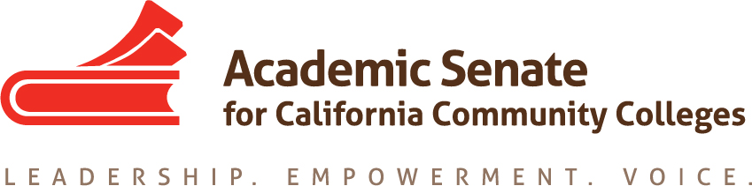

Educational Policies Committee
April 12, 2017
3:00 pm – 4:00 pm

CCC Confer
1-913-312-3202 OR 1-888-886-3951
Presenter Passcode: 6911678
Participant Passcode: 681721

MINUTES

Members Present: Ginni May, Randy Beach, Donna Greene, Michael Flores, Andrea Devitt, Saleem Moinuddin

- Select note taker – G. May

- Approval of Agenda – approved

- Approval/Review of minutes – approved online

- Paper – Effective Practices for Educational Program Development
Update: Current draft will be given to the 2017/18 Educational Policies Committee to finish. Both committees, 2016/17 and 2017/18 will be credited.

- AB 1985 Survey and Policy for AP Examination Course Credit in the California Community Colleges
Update: Policy went out March 30, 2017.

- Dual Enrollment Update – Donna Greene

- Update on Rostrum Article:
March Plan: Donna and Dre will work with the draft of Michael to send Ginni a draft by April 27/28. From there Ginni will polish it a bit and send it off for the next Rostrum. This article will have just the author’s names, not the entire committee.

- Plenary Session: April 20-22 at the San Mateo Marriott

- Future Meetings/Events – There may be one more phone meeting…Ginni will check for need after plenary and email the group. It was suggested that some or all of us consider meeting with next year’s chair and committee to launch them with the paper.

- Future Agenda Items – right now, we have none

