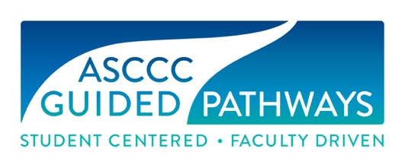

Guided Pathways Task Force Meeting
Minutes
Wednesday, March 17, 2021
11:00 am – 1:30 pm
Virtual

Members Present: Cheryl Aschenbach, Michelle Bean, Juan Buriel, Stephanie Curry, Sam Foster, Sarah Harris, Jeffrey Hernandez, Ginni May (Chair), Meridith Selden, Erik Shearer

Staff Present: Miguel Rother, Selena Silva

- Meeting called to order at 11:07 am

- Members checked-in

- Minutes from the February 10, 2021 GPTF Meeting were approved by consensus.

- The chair shared that the Executive Committee members are reviewing their Standing Committee charges with a focus on clarifying GP and DEI elements in their work; Area meetings are taking place next week and all are welcome, resolutions are due April 9 and the Spring Plenary Session begins April 15. It was also shared that elections for the Executive Committee are coming up. Folks were encouraged to run, ask questions, and to also apply for Statewide Service.

- The Webinars chair reported that all webinars have been scheduled. One webinar took place today, and the others are set to go.

- The Technical visits chair reported that requests are slow this spring. One request has been received. It was noted that some colleges may be pretty far along in their GP implementation, while others may have set it aside for the time being to care of more pressing issues.

- The Resources team will utilize time during the April GPTF meeting to go through the GP Canvas courses and incorporate the suite of resources currently under development. It was noted that perhaps the GP Canvas courses could be set up as a Canvas Commons course. This possibility will be investigated.

- The GPTF shared their progress on each of the Mini Canvas courses in the Suite of Resources being developed. GPTF members will provide links and updates to resources and send to May for her report to the Executive Committee.

- The GPTF reviewed the draft survey to evaluate placement in English, English as a Second Language, and mathematics pathways in response to Resolution F20 18.01. May and Aschenbach will share with AB 705 Collaboration group, update based on comments, share with the GPTF for final feedback and prepare for the April Executive Committee Meeting. In addition, May will work with ASCCC staff to format in a Survey Monkey, pending the Executive Committee feedback and approval at the April 14 meeting, so that the survey may be disseminated at the earliest possible date.

- It was discussed that April meeting will include a walkthrough and editing of the GP Canvas Courses. The May meeting will include a report from each GPTF member on Rostrum Articles, resolutions and resources for May to include in the final GPTF report.

- Meeting adjourned at 12:57 pm/

