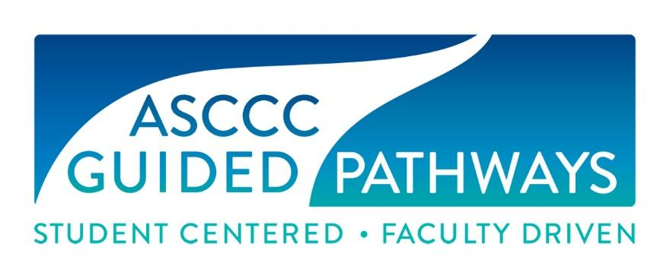
ASCCC Guided Pathways Task Force Meeting (GPTF)
Wednesday, August 21, 2019
Embassy Suites Riverfront Promenade, Sacramento, CA
10:00 a.m.- 3:00 p.m.

In Attendance
Jessica Alabi, ASCCC Guided Pathways Faculty Lead, Orange Coast College
Julie Bruno, Communications Faculty, Sierra College, ASCCC Past-President
Mayra Cruz, ASCCC Area B Representative
Nate Donahue, ASCCC At-Large Representative, Santa Monica College
Janet Fulks, ASCCC Guided Pathways Faculty Lead
Jeffrey Hernandez, ASCCC Guided Pathways Faculty Lead
Virginia May, Chair, Guided Pathways Taskforce
Timothy Pawalk, Business and Computers information Technology, Sand Diego Continuing Ed.
Meridith Seldon, Yuba Community College, Psychology Faculty
Ty Simpson, ASCCC Guided Pathways Faculty Lead
Eric Thompson, Humanities Faculty, Santa Rosa Community College
Eric Wada, C-ID Co-Curriculum Director

Staff
Krystinne Mica, ASCCC Executive Director
Miguel Rother, ASCCC Director of Grants and Initiatives
Jennifer Valencia, ASCCC Program Manager

- Introduction and Announcements
Chair May called the meeting to order at 10:00 a.m.

- Approval of Agenda and previous
Agenda was approved by consensus.

- Scope of Work, Goals and Expectations
Mica discussed the Guided Pathways (GP) Statement of Work (SOW) with the group. The SOW was written to allow flexibility as the needs and goals of GP evolves. The group reviewed the attachment/graphic that shows the GP pillars.

Follow up: The GP pillars graphic will be edited to include the GP Taskforce goals.

- Basecamp
Rother provided a brief overview of the Basecamp application. Members discussed the benefits of utilizing the application. The group requested that a training session be scheduled for a more in-depth training of Basecamp. By consensus, group members agreed to move forward with the utilization of Basecamp as a project management tool.
No Action by motion was taken by this action.
Follow up: Rother will schedule office hours to provide online training on the Basecamp application.

- Tools
Fulks provided an overview of the challenges and achievements regarding GP tool development. The group discussed collaborative tool development efforts with other organizations such as the Research and Planning (RP) Group, and the Career Ladders Project. It was noted that the GP taskforce should continue to create tools for colleges in addition to these collaborative efforts. Tools are to be custom made for individual colleges granting them the freedom to create their own tools focusing on guidelines and majors. Group members discussed the proposed GP logos and suggested edits. The group agreed to move forward with the use of a new logo with suggested edits.

Follow up: Edits will be made to the GP logo.

- Presentations
Task Force members discussed the importance of ensuring that leads and presenters are assigned to presentations related to guided pathways, and that resources are available to members, such as PowerPoint decks to be utilized when putting together presentation materials. It was also noted that past presentation materials are currently housed in an accessible, communal account in Canvas.

Follow up items:
- GP Staff will create a PowerPoint deck using the new GP logo.
- Members of the task force will attempt to reach rural colleges by facilitating regional meetings.
- GP presentations will be held at the ASCCC Academic Academy and Fall Plenary.
- Presentation materials will be stored in Canvas and Basecamp.

- Events
A. Guided Pathways Fall regional meetings
May and Mica will discuss possible meeting dates and locations. The goal is to target community colleges in rural areas in the north and south regions. The meeting dates and locations are to be determined for October and November. The target audience is the senate president, academic representative, GP liaisons, student representatives and faculty members.
B. Academic Academy
Faculty diversity, equity, and online tech to take place on 9/12-14 along with partnering student senate. Students will also be presenting.
C. Fall Plenary- resolutions, breakout sessions
Potential resolutions to bring forward at Fall Plenary were discussed. May submitted the following breakout session topics: Guided Pathways in years 3, 4, 5 and the role of the ASCCC; Scale of Adoption Assessment (SAA); and Guided Self Placement for All.

Follow up: Resolutions are due to Ginni by September 3, 2019.

- Data
The group discussed the importance of analyzing both qualitative and quantitative data sets, as well as revisiting best practices, in order to ensure that the GP project remains relevant and current to the evolving needs of colleges and students. Group members discussed collaboration with the Research and Planning (RP) Group, as well as several data guidelines for Guided Pathways.

- Rostrum
The group discussed topics for Rostrum articles to be included in the Fall Plenary Rostrum and agreed on four topics. It was noted that submissions are due by September 26, 2019.

Article | Appointed to Members
The state of meta majors in the CCC | Fulks and Donahue
Counseling faculty and senates AS Representation | Hernandez and Simpson
Major Selection and Student Engagement  - Using student assignments to implement student voice, for input with scheduling. | Alabi

Follow up: Rother will add a reminder for the Rostrum due date of
September 18, 2019.

- Pillar 4
The group discussed the importance of, and ways to support faculty to ensure that they feel empowered and not isolated. Suggestions were made to partner with 3CSN to host regional meetings directed towards part-time faculty, and to look into funding to pay part-time faculty to attend institutes or regional meetings.

Task force members were assigned to the teams below for the upcoming year:

Areas | Communications and Statewide Committees | Canvas Website | Webinars | Presentations | Tools | Guided Pathways Liaison Support | Technical Visits
Lead | Krystinne | Ty | Jessica | Ginni | Janet | Jeffrey | Ginni
Co-Lead | Ginni, Julie | Nate | Janet | Mayra | Nate | Ginni | Janet
Members |  | Janet  Meredith | Jeffrey  Ty  Timothy |  | Eric T  Eric W  Mayra  Meredith | Julie  Jessica

- Future Agenda and Items and Meeting Times
Possible dates for regional meetings are Thursday October 24th, Friday October 25th, Friday November 1st and Friday Nov 22nd. On Friday November 1st and 22nd two meetings will be held for the North region and South region on the same date. The next GP meeting will be held on October 1st in person at Santa Monica College at 10:30am to 3:00pm. A Zoom meeting is to be set up for the 4th of Sept 8:00am.

Meeting called to an end at 3:00pm.
Respectfully submitted by:
Jennifer Valencia, ASCCC Program Manager

