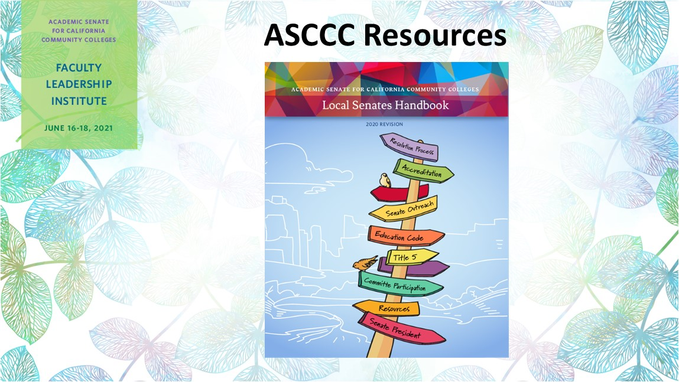

Resources for Local Academic Senate Leaders

ASCCC Local Senates Webpage

ASCCC 10+1 Webpage

ASCCC 10+1 Infographic

ASCCC Area Map

ASCCC New Membership Brochure

ASCCC New Membership Card

ASCCC Local Senates Handbook 2020
Program and Course Approval Handbook (PCAH 7th Edition)

Minimum Qualification/Disciplines List

Summer 2020 Rostrum

November 2020 Rostrum

The Brown Act.

ASCCC Faculty Application for Statewide Service

ASCCC Signup for Newsletters and Listservs

Equity Driven-Systems: Student Equity and Achievement in the California Community Colleges

Trying to figure out all the acronyms? Here is a list of the ACRONYMS 2012.pdf

If you need more information please Contact Us: Use the Form or email to info@asccc.org

