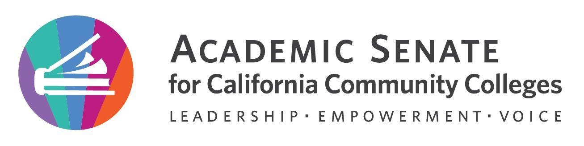

ASCCC AREA B MEETING **DRAFT**

Friday, March 24, 2023

10am-3pm

AGENDA

- Call to Order
- Adoption of the Agenda

- Welcome! & Attendance
Sign-in sheet (Google): https://docs.google.com/spreadsheets/d/1bbfTx7gorYkIqtlkrHoSymwNyU_iVaNaU5l2TkibRhY/edit?usp=sharing

- Reports
    - ASCCC Presidents Report – ASCCC President Ginni May

- Resolutions
    - Review of Resolutions Process-- Resolutions Committee
      - Resolutions Spring 2023 Process Overview PPT
      - Resolutions Link Tree
      - Spring 2023 Delegate Change Form
    - Review of Packet of Resolutions for Area Discussion-- Karen Chow
    - Additional Resolutions from the Area -- Karen & all
      - Other Resolutions being carried to Area B meeting by attendees

- Disciplines List
    - Timelines
      - From Disciplines List website: “In February, the process for formally reviewing the Disciplines List, which establishes the minimum qualifications for the faculty of California community colleges, was initiated. This letter serves as a notification that the ASCCC is currently accepting proposals to revise the Disciplines List for the 2022-2023 cycle. As a reminder, the review process is now an annual process. The deadline for submission of proposals is September 30, 2022. Proposals received after the deadline may be held for the 2023-2024 cycle.”
    - Proposals:
    - Hearings : Friday, April 21, 8:00 AM -9:00 AM at Spring Plenary.
The Disciplines List information is now available online via the webpage here: https://asccc.org/disciplines-list

- ASCCC Foundation Report- ASCCC Foundation
  - THANK YOU in advance for any and all ways you donate to support the work of the ASCCC Foundation, which serves to support faculty leadership and professional development through scholarships to attend Plenaries and Institutes and Innovation Grants! https://asfccc.com/

- Reports and Updates from Local Colleges
Please share here: https://docs.google.com/spreadsheets/d/1bbfTx7gorYkIqtlkrHoSymwNyU_iVaNaU5l2TkibRhY/edit?usp=sharing

- Announcements/Events
- ASCCC Webinars on ASCCC Events Calendar
- 2023 Spring Plenary (April 20-22, 2022)
- 2023 Faculty Leadership Institute (June 15-17, 2023)
- 2023 Curriculum Institute (July 12-15, 2023)

- Adjournment

