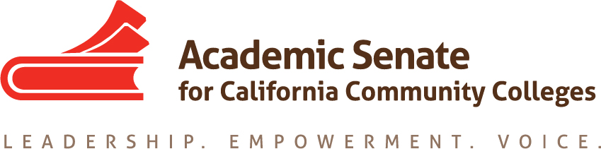

ACADEMIC SENATE FOR CALIFORNIA COMMUNITY COLLEGES
AREA C MEETING
Saturday, March 24, 2018
10:00 am - 3:00 pm
(Continental Breakfast at 9:00)
Glendale College
Administration Building, Room AD 317
1500 North Verdugo Road
Glendale, CA 91208

- Welcome and Introductions

- Area C meeting for Fall 2018-Spring 2019?
  - Fall 2018
  - Spring 2019

- Reports (given during lunch)
  - ASCCC Update – Julie Bruno, President ASCCC
    - Guided Pathways
    - Budget/Legislative Updates
  - Academic Senate Foundation for CCC, John Freitas, ASCCC Foundation Secretary

  - ASCCC Elections
    - Positions Available
    - Process & Application
  - Disciplines List, John Freitas, ASCCC Treasurer
    - Overview of Disciplines List Revision Process
    - Submitted Proposals

- Resolutions
  - Resolutions Process – Michael Dighera, Area C Representative on Resolutions Committee
    - Resource: Resolutions Handbook
  - Review and discussion of pre-session resolutions
(Click “Resolutions” to download the resolutions packet and the appendices)
  - Development and discussion of Area C resolutions

- Reports From Colleges

- Announcements
  - Meetings/Institutes – Registration Now Open!
    - Equity and Diversity Action Committee (EDAC) Regional South Meeting – April 7, 2018
    - Career and Noncredit Education Institute, May 3-5, 2018
    - Spring Curriculum Regional South, May 19, 2018
    - Faculty Leadership Institute, Jun 14-16, 2018
    - Curriculum Institute, Jul 11-14, 2018
    - Part-time Faculty Leadership Institute, Aug 2-4, 2018
  - Upcoming Executive Committee Meetings
    - April 11, 2018, San Mateo Marriott
    - June 1 -3, 2019, Hotel Pacific, Monterey

- Adjournment – See you at plenary!

