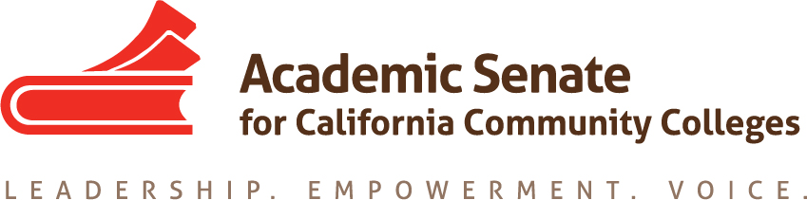

ACADEMIC SENATE FOR CALIFORNIA COMMUNITY COLLEGES
AREA C MEETING
Saturday, March 24, 2018
10:00 am - 3:00 pm
(Continental Breakfast at 9:00)
Glendale College
Administration Building, Room AD 317
1500 North Verdugo Road
Glendale, CA 91208

- Welcome and Introductions – participants were given an opportunity to introduce themselves.

- Area C meeting for Fall 2018-Spring 2019? Call for volunteers
  - Fall 2018 – Rio Hondo volunteered for fall 2018.
  - Spring 2019 – Mt. SAC and Citrus College volunteered for spring 2019.

- Reports
  - ASCCC Update – Julie Bruno, President ASCCC
Online College – skepticism in the legislature. Offerings will be competency based if it happens. Among skeptics include Assemblymember Jose Medina, chair of Assembly Education Committee. Funding is from Proposition 98 money. Unions are concerned because Rio Solado (Arizona), which employs only part-time faculty, is used as the model. Academic Senate is to bring together the 114 colleges in a consortium to accomplish the stated goals of the online college. Will pursue DEAC accreditation (national accreditor), and eventually ACCJC accreditation. The Chancellor’s Office has a website and is having listening sessions across the state.

Funding Formula – Chancellor’s Office brought together a group of CEOs and CBOs to develop recommendations for the proposed new funding formula. Key points include expanding the timeline to 7 years, starting with 95% access/5% metrics in year 1 to 75% access/25% metrics in year 7.

Work Group on Regulations (“Sacred Cows”) – 50% law and FON. Work group has reconvened. Counselors and librarians, tutors, faculty reassigned time for instructional activities, curriculum development, and governance to be included in 50% law. FON is now the 75% goal. FT faculty hiring should be a priority, including budget advocacy by CCCCO. CCCCO should track progress, BOG should monitor, and there should be a 10% improvement. Noncredit faculty should be included. Report should be submitted to BOG, with sign off from senate president, union president, and college president.

Guided Pathways – Work plan due March 30 with senate president sign off. These are not static documents. There are IEPI workshops on guided pathways. Governance issues have arisen as a result of GP conversations at colleges.

Legislation – SB 1009 (Wilk) will allow noncredit tutoring apportionment, tutoring for all students, no referral needed. AB 1935 (Irwin) similar, but doesn’t include basic skills. AB 1935 is supported by the BOG and sponsored by the Chancellor’s Office. AB 2248 (McCarty) changes CalGrant definition of a full time student from 12 units to 15 units per semester and from 24 to 30 units per year. AB 1805 (Irwin) would require a community college to annually report to the Office of the Chancellor of the California Community Colleges the community college’s placement policies and placement results, and would require a community college to publicly post its placement results. SB 1406 (Hill) extends baccalaureate sunset.

AB 705 – The guidelines were sent out by the Chancellor’s Office on 3/22. Attendees reported on status at campuses. A comment was made about divisions between math faculty. Another comment was made about the need to retrain faculty and the need for more statistics courses and professional development.

Challenges – Chancellor’s Office consultation with the ASCCC challenges were discussed.

    - Guided Pathways
    - Budget/Legislative Updates
  - Academic Senate Foundation for CCC, John Freitas, ASCCC Foundation Secretary
John Freitas provided information about the Area Competition and the Spring Fling.

  - ASCCC Elections
Rebecca Eikey provided an overview of the elections process.
    - Positions Available
    - Process & Application
  - Disciplines List, John Freitas, ASCCC Treasurer
John Freitas provided an overview of the process.
    - Overview of Disciplines List Revision Process
    - Submitted Proposals

- Resolutions
  - Resolutions Process – Michael Dighera, Area C Representative on Resolutions Committee
Michael Dighera provided an overview of the resolutions process.
The Executive Committee resolutions were discussed.
New resolutions were brought forward and discussed.
    - Resource: Resolutions Handbook
  - Review and discussion of pre-session resolutions
(Click “Resolutions” to download the resolutions packet and the appendices)
  - Development and discussion of Area C resolutions

- Reports From Colleges
Updates from participants was shared.

- Announcements
  - Meetings/Institutes – Registration Now Open!
    - Equity and Diversity Action Committee (EDAC) Regional South Meeting – April 7, 2018
    - Career and Noncredit Education Institute, May 3-5, 2018
    - Spring Curriculum Regional South, May 19, 2018
    - Faculty Leadership Institute, Jun 14-16, 2018
    - Curriculum Institute, Jul 11-14, 2018
    - Part-time Faculty Leadership Institute, Aug 2-4, 2018
  - Upcoming Executive Committee Meetings
    - April 11, 2018, San Mateo Marriott
    - June 1 -3, 2019, Hotel Pacific, Monterey

- Adjournment – See you at plenary!

