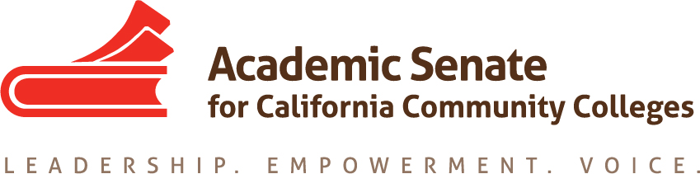

Basic Skills Committee

Thursday September 24th, 2018

4:00 PM – 5:30 PM

Join from PC, Mac, Linux, iOS or Android: https://cccconfer.zoom.us/j/3285687631

Or iPhone one-tap (US Toll): +14086380968,3285687631# or +16468769923,3285687631#

Or Telephone:

Dial:

+1 408 638 0968 (US Toll)

+1 646 876 9923 (US Toll)

Meeting ID: 328 568 7631

- Order of the Agenda
- Welcome and Introductions
- AB 705 Regional Meetings
- Research on Corequisite Model
- Update from Committee Members on AB 705 Implementation
- Future Meeting Date
- Other

