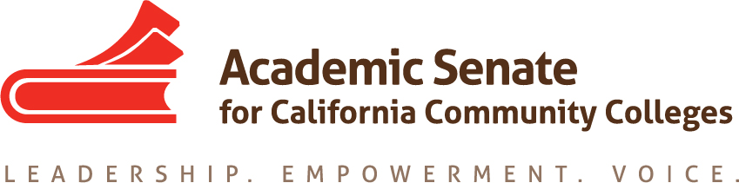

Basic Skills Committee

Thursday August 30th, 2018

4:00 PM – 5:30 PM

Members Present: Craig Rutan, Micheal Wyly, Geoffrey Dyer, Ekatia Fuchs, Claudia de la Toba, and Kathryn Wada

Meeting called to order at 4:06 PM

- Welcome and Introductions: The committee members introduced themselves.

- Review of Committee Charter: The committee reviewed its charge. No changes were suggested.

- Review of Assigned Resolutions: There are three resolutions assigned to the committee, all related to ESL. Resolution 7.11 F17 may become moot if the Student Success Scorecard is replaced with a new report. The Chancellor’s Office is creating a group to revise CB21 in light of AB 705 and it is hoped that many of the issues related to CB21 for ESL will be addressed by that group. 7.06 and 7.07 from S18 both relate to ESL and the implementation of AB 705. The AB 705 ESL Workgroup is continuing to work through the fall and the committee will assist colleges with local implementation once additional guidance is available.

- AB 705: Committee members were provided with the two guidance memos, one for mathematics/quantitative reasoning and English and one related to ESL, and the frequently asked questions (FAQ) document distributed in August. Each of the committee members shared the implementation efforts underway at their colleges. All of the colleges represented on the committee are currently investigating some curricular reforms and some colleges are piloting new support courses in spring. Adjusting course schedules was mentioned as a potential challenge that colleges will be facing. None of the colleges represented on the committee have fully implemented all of the local changes necessary for mathematics, English, and reading. The committee will need to support colleges as they attempt to comply with AB705’s requirements. This may be done with a combination of Rostrum articles, webinars, regional meetings, and conference presentations. The focus will be on mathematics, English, and reading in the fall with additional emphasis on ESL once additional guidance has been released.

- Possible Regional Meetings: The committee discussed the possibility of regional meetings. C. Rutan informed the committee that the regional meetings are likely to be in collaboration with the Curriculum and Noncredit Committees. While regional meetings early in the fall term would be preferred, they may not be possible due to the number of other professional development opportunities that have already been scheduled. The committee may also offer webinars on the implementation of AB 705, similar to those being offered by CATESOL, RP, ACCE, and other groups throughout the system.

- Future Meeting Dates: Monday afternoons were identified as possible days for Zoom meetings. C. Rutan will send out a Doodle poll with possible times on September 24th for the next committee meeting.

- Other: AB1805 (Irwin) has moved forward and is likely to be adopted by the California Senate. If it is signed by the Governor, colleges will be required to inform students of their rights to transfer level courses in mathematics and English and to report their placement practices to the Chancellor’s Office. Colleges that fail to comply could lose their Student Equity and Achievement Program funding. If adopted, the bill would ensure that colleges are complying with the requirements of AB705.

Meeting Adjourned at 5:13 PM

Respectfully submitted,

Craig Rutan

Approved September 4, 2018

