CCC Herndon Center Information

Address: 390 W Fir Ave, Clovis, CA 93611
Parking
Parking will be relaxed on the day of the workshop. Park anywhere at the site.
Location: Workshop Held in Room 308

Building B Map
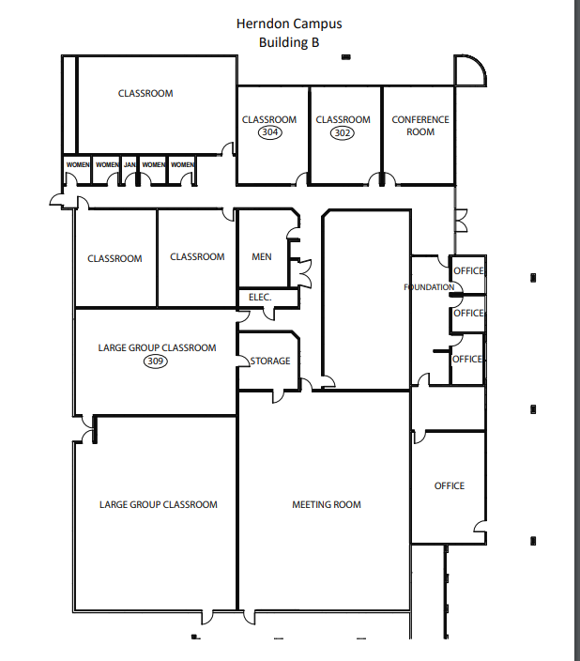
Room 308

