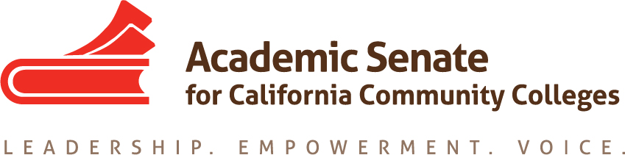

Curriculum Committee

Tuesday February 20, 2018

4 PM – 5:30 PM

Members Present: C. Aschenbach, K. Daar, L. Hector, D. Keller, C. Reiss, C. Rutan, A. Tran, E. Wada, T. Winsome

Meeting began at 4:01 PM

Logistics for March 17 meeting at LA Valley College: The committee will be meeting in person on March 17th and LA Valley College from 10 AM until 3 PM. If committee members have not already made their travel arrangements, please submit a travel request to ASCCC by the end of the week. Please email C. Rutan if you will be attending the meeting and if you will be flying. Burbank is the closest airport to the college, but some members may need to fly into LAX. Either C. Rutan or C. Aschenbach can pick people up from the Burbank Airport. If you are driving to the meeting, please email K. Daar for a parking permit.

Update on AB 705: The AB 705 Implementation Committee has met three times and the group has discussed defining specific terms in the bill and providing guidance to colleges on placement using high school performance data. A memo will be distributed by the Chancellor’s Office in March. There will be presentations at Spring Plenary. The last scheduled meeting for the Committee is February 26, but it appears that additional meetings will be needed. The ESL Workgroup for AB 705 will have its first meeting on February 26th after the advisory committee meeting.

Spring Plenary Breakouts: The Curriculum Committee will have two breakouts at the Spring Plenary Session. Curriculum Hot Topics will be presented by C. Rutan, C. Aschenbach, and E. Wada. Curriculum and Guided Pathways will be presented by C. Aschenbach, R. Beach, and T. Winsome. Any committee members attending the plenary session are encouraged to attend the committee’s breakouts.

Cover Art for Curriculum Institute: The committee was asked to suggest possible cover art for the Curriculum Institute program. The proposal includes road signs pointing in many different directions in the foreground and students holding their degree in the background. In between there will be clear pathways leading to the students. A draft of the cover will be shared with the committee before it is finalized.

Spring Regional Topics: The Executive Committee approved holding spring regional meetings on May 18th and May 19th. The meeting on May 19th will be at LA Trade Technical College. A location for the May 18th meeting is still be sought, but the meeting is likely to happen in the Bay Area. AB 705 will be part of the regionals, but committee members should think of other possible topics. The agenda for the regional meetings will be set at the March 17th meeting.

Rostrum Articles Related to Resolutions 9.04 F 2012 and 17.03 S 2017: Resolution 9.04 F2012 is related to the importance of major preparation courses for transfer students. L. Hector, A. Tran, and C. Rutan will put together an article to address the resolution. Resolution 17.03 S2017 is about the role of local faculty and academic senates with apprenticeship programs. T. Winsome and C. Rutan will work on an article for this resolution. A presentation at the Curriculum Institute may also be needed to satisfy the resolution. Rostrum articles are due by March 5th.

The next Curriculum Committee meeting will be on March 17th at LA Valley College.

Meeting adjourned at 4:54 PM

Respectfully submitted,

Craig Rutan

Approved March 12, 2018

