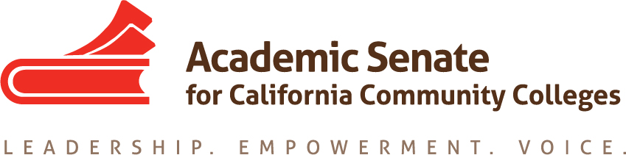

Curriculum Committee

Friday September 1, 2017

9:30 AM – 11 AM

Members Present: C. Aschenbach, K. Daar, D. Keller, L. Hector, C. Reiss, C. Rutan, A. Tran, E. Wada, and T. Winsome

Meeting called to order at 9:30 AM

Committee Charge: The committee reviewed the charge of the Curriculum Committee and does not plan to make any changes at this time.

Committee Priorities: C. Rutan presented the committee with a list of resolutions assigned.

- Developing a Reference Document for Curriculum (9.01 F10): The primary reference documents the committee will be updating at the Curriculum 101 modules from the Professional Development College (PDC) and the ccccurriculum.net website. All committee members will review these resources and compile a list of necessary updates/revisions by the September 27 committee meeting.
- Ensuring Availability of Major Preparation (9.04 F12): The 2016-17 Curriculum Committee suggested writing a Rostrum article and C. Rutan will work with A. Tran on that article this fall.
- Oppose External Honors Programs (9.11 F15): The 2016-17 Curriculum Committee attempted to contact the Honors Transfer Council of California (HTCC) to determine if any further action is necessary, but no response was received. T. Winsome will work with her local honors coordinator to try and determine if the HTCC believes any further action by ASCCC is needed.
- Placement Model for Statistics Using High School Transcript Data (18.02 S16): The committee will begin developing a survey to the field at the September 27 meeting.
- Student Learning Outcomes Assessment is a Curricular Matter (9.06 S16): Members of the Curriculum Committee will work with members of the Accreditation Committee to update the ASCCC SLO Glossary and to develop a paper on Student Learning Outcomes. The following committee members volunteered to work on these projects: C. Aschenbach, D. Keller, C. Reiss, E. Wada, and T. Winsome
- Local Senate Purview and Apprenticeship Programs (17.03 S17): T. Winsome will work with C. Rutan to develop a Rostrum article in late fall or early spring. A breakout presentation will be part of the 2018 Curriculum Institute and additional presentations may be needed at plenary sessions and the fall curriculum regional meetings.

Fall Regional Meetings: The committee will be presenting regional meetings on November 17th (Notrth) and 18th (South). Committee members in the north were asked to be available to assist at the November 17th regional and those in the south to be available on the 18th. Both regional meetings will include presenters from the Chancellor’s Office. Development of the program for the regionals will be discussed at the September 27th meeting.

Curriculum Institute Theme: The Curriculum Institute theme will need to fit with the overall theme for all 2017-18 ASCCC Institutes and Plenary Sessions, change. Committee members were asked to think of possible themes and to be ready to decide on a theme for the institute at the September 27 meeting.

Fall Plenary Session Breakouts: C. Reiss and T. Winsome are both planning to be at the plenary session and are available to present. C. Rutan encouraged other interested faculty members to speak to their local administration to see if funding is available to attend plenary. Committee breakouts will be set at the Executive Committee meeting in Sacramento and C. Rutan will reach out to committee members to present once the breakout topics are determined.

Schedule Future Meetings: The next two committee meetings will be held via Zoom on September 27 (3:30 PM – 5 PM) and October 20 (8:30 AM – 10 AM). An in-person meeting to begin planning of the Curriculum Institute may not be possible until December or January.

Meeting adjourned at 10:54 AM

Respectfully submitted,

Craig Rutan

Approved September 8, 2017 (via email)

