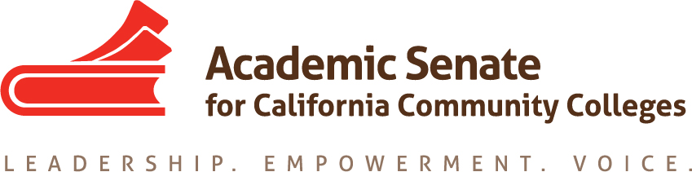

Career Technical Education Leadership Committee (CTELC)

CTE Liaisons April 2021 Memo
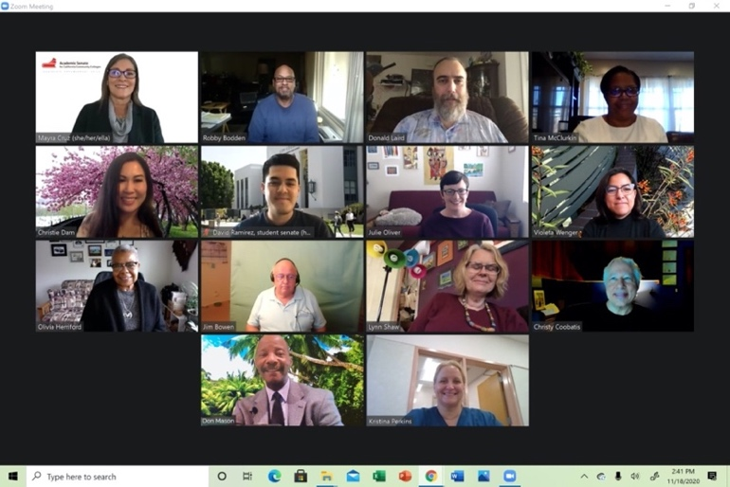
Dear CTE Liaisons,

Since the 1970s, ASCCC has been committed to the diversification of faculty in our community college system. Faculty diversification has become a critical goal for our system and colleges over the past 3 years. CTE Liaisons are encouraged to learn about the local hiring process. Today’s commitment to diversity, equity and inclusion and antiracist agenda requires the review of structural, human, and campus cultural factors that are part of the hiring process. Become informed! The Career Noncredit Institute is this Friday and Saturday. Join us!

--The 2020-2021 CTE Leadership Committee
Mayra E. Cruz, CTE Leadership Committee Chair, Julie Oliver, 2nd Chair
Emilda Baghdaserians, Robert Bodden, Jr., Jimmie Bowen, Christy Coobatis,
Christie Dam, Olivia S. Herriford, Donald Laird, Don Mason, Tina McClurkin,
Kristina Perkins, David Ramirez, Lynn Shaw, Violeta Wenger

CTE Faculty Diversification

The California Community College systems serves as the catalyst for the economic mobility of Californians and most suitable to serve populations marginalized by the social, economic and educational system’s history of racism. As published by the California Community Colleges Chancellor’s Office Diversity, Equity and Inclusion (DEI) Workgroup on the literature review in May of 2019, “Literature on campus diversity efforts look at ethnic and racial diversity through the lens of faculty, staff, and students, with consistent themes of recruitment, retention, and support.” The review of the literature also revealed “the need for system level commitment to faculty, staff, and student diversity to ensure we are supporting our students towards completion of their academic goals and closing educational attainments gaps among historically underserved student populations.”

To uphold a commitment to diversity, colleges must address representation and diversity in CTE programs through various means including the diversification of CTE faculty, the CTE advisory boards and college outreach programs. Diversification strategies foster inclusive institutions and environments for all students to thrive.

One step towards CTE faculty diversification can be achieved by learning to use the Career Technical Education Faculty Minimum Qualifications Toolkit. The toolkit is designed to assist local academic senates, discipline faculty and equivalency committees to review the experiences and expertise CTE faculty candidates bring and provides a mechanism through which a candidate may meet minimum qualifications. The toolkit provides maximum flexibility in the use of equivalency to create a diverse and qualified pools of industry expert candidates for our Career Technical Education programs.

Resources

Aschenbach, Cheryl & Roberson, Carrie. (October 2019). Introducing the CTE Minimum Qualifications Toolkit. https://www.asccc.org/content/introducing-cte-minimum-qualifications-toolkit

California Community College Chancellor’s Office. (May 2019) Literature Review on Faculty, Staff, and Student Diversity.
https://73767B97C2DE63FCE1518BB4B39B6278C5500ACFwww.cccco.edu/-/media/CCCCO-Website/Files/Communications/vision-for-success/2-literature-review-on-faculty-staff-and-student-diversity.pdf?la=en&hash=

Davison, Dolores & Cruz, Mayra. (February 2021) Faculty Hiring & Diversity: Ongoing Collaborative Effort, ASCCC Rostrum.
https://www.asccc.org/content/faculty-hiring-and-diversity-ongoing-collaborative-effort

Technical visits, including training your Equivalency Committee, as requested (https://www.asccc.org/contact/request-services)
Career Technical Education Faculty Minimum Qualifications Toolkit https://asccc.org/sites/default/files/ADAversion_CTEMinQualsToolkit.pdf

Upcoming Events

2021 Career Noncredit Education Institute - Virtual Event
April 30-May 1, 2021

CTE Liaison Coffee Hour - Preparing for Next Academic Year
May 6, 2021
1:00-2:00 PM

CTE Discipline Specific Gatherings
May 14, 2021
12:00-1:00 PM

To request support or information email info@asccc.org

California Community Colleges Chancellor’s Office Diversity, Equity and Inclusion (DEI) Workgroup Literature Review on Faculty , Staff, and Student Diversity. (March 2019) https://www.cccco.edu/-/media/CCCCO-Website/Files/Communications/vision-for-success/2-literature-review-on-faculty-staff-and-student-diversity.pdf?la=en&hash=73767B97C2DE63FCE1518BB4B39B6278C5500ACF

