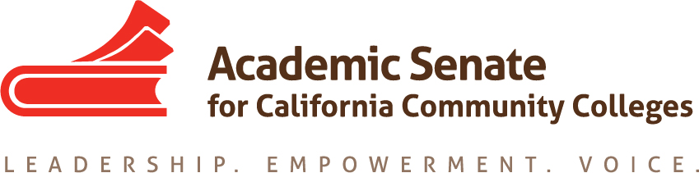

Career Technical Education Leadership Committee

October 14, 2020

12:45-2:30pm

Meeting Minutes

- Welcome-Mayra Cruz, Julie Oliver, Lynn Shaw, Kristina Perkins, Christie Dam, Olivia Herriford, Elmida Baghdaserians, Robby Bodden, Angelica Campos, Miguel Rother, Donald Laird, Violeta Wenger, Christy Coobatis, Tina McClurkin

- Call to Order and Adoption of the Agenda

- Check-in (All)-Individual welcomes and check-ins by all members.

- Approval of the September 23, 2020 meeting minutes-Approved

- Basecamp training (ASCCC Director of Grants & Initiatives Miguel Rother)

  - Miguel walked the group through the features of Basecamp
  - Focus Area Team Leads should be adding “To-Dos” as they arise, and others may also add items to the list
  - Basecamp is also possible to use on phones
  - All meeting docs (agendas and notes) will be in one folder

- Reports
A. Student Senate CCC (Angelica)
- Equity Diversity Inclusion theme has been the focus
- Immigrant issues
- Antiracism plan of action created after townhalls and listening sessions
- Working with student body organizations to help implement plan of action
- Fall Plenary-“Grow Your Own Base” need more faculty and classified that represent the student body
- Educational curriculum that represents student needs and wants, such as more Ethnic Studies courses
- Deaf Awareness Townhall being scheduled to help bring awareness of deaf students in CCC system
- Lots of advocacy to empower students who are on boards of trustees
B. Academic Senate CCC (Mayra/Julie)
- Fall Plenary registration now open; Addressing AntiBlackness and IDEAs in Academic and Professional Matters
- Exemplary Program Award nominations open due Nov 9th
- Summer-successful institutes (leadership and curriculum)
- Area meetings this Friday and Saturday

C. Fall Plenary breakout sessions assignments (Mayra)
- Grow Your Own-Elmida, Angelica
- Equity Law Enforcement and in First Responders & Training-Mayra, Lynn, Don

- Community norms proposed addition for CTELC (Lynn)
  - Add, “Recognize that there is white privilege and that anti-racism is a focus of your work together.”

- Focus Areas Teams Report (Leads and members)
- Committee priorities
  - Identified committee goals at first meeting
  - Reviewed each individual resolution to determine what has been done and what still needs to be done
  - Review CTE Liaison surveys
  - Assigned duties and timelines
  - Trying to schedule monthly meetings
  - Minutes loaded on Basecamp
- Communication and Support to CTE Liaisons
  - October memo to be created to send to CTE Liaisons
  - Reviewing the CTE survey with a lens for communication, determining top 3-5 priorities
  - Creating communities of support among CTE Liaisons. ASCCC provided a list of all CTE Liaisons.
  - Regional Consortia Chairs are very interested in collaborating with us on projects, including co-funding. These may include professional development, communities of practice, or other ideas we would like. Also sent a long list of free resources to Lynn which se forwarded to Mayra.
- Professional Development and Learning
  - Planning out a program for virtual sessions, with guidance on topics from CTE survey, will be selecting 7-8 topics and creating a calendar for PD
  - Updating the Canvas module
  - High interest in technology alignment and support of lab classes, and equity and anti-racism
  - Olivia would like a co-lead for this group to cover when she is unable to attend. Tina will be co-lead.
  - Career NonCredit Education Institute (April 30-May 2, 2021) in collaboration with the NonCredit Committee- November 19th joint meeting
  - Webinars, Zoom sharing sessions, conversations program
  - Update Canvas module: Focus on Career/Technical Education
- Next meeting (Mayra)
November 18 2:30pm

- Next meeting topics (All)
  - GE use of Perkins equipment issue (Christy)

- Upcoming events
- Fall Plenary 2020 (November 5-7)
Theme: Addressing Anti-Blackness & IDEAs (Inclusion, Diversity, Equity, and Anti-Racism) in Academic and Professional Matters

- Announcements
  - Events
  - Application for Statewide Service – http://asccc.org/content/application-statewide-service
  - Other (from members)
    - Robby, Evergreen Valley College, auto dept collaborating with correctional facility to start a program there. Pilot program this spring.
    - Christie-cooperative work experience faculty met with Nexus Edge to talk about badging backed by industry.

- Adjournment

Status of Previous Action Items

- In Progress (include details about pending items such as resolutions, papers, Rostrums, etc.)
  - Focus area team plans
  - Focus area team lead role

- Completed (include a list of those items that have been completed as a way to build the end of year report).
- Committee charge review
- Fall 2020 Plenary breakout assignments
- 20-21 Action Plan components review and formation of focus area teams (3)
- CNEI Marketing blurb
- Fall Rostrum article Credit for Prior Learning as an Equity Lever Co-Authors: Jackie Martin, Chantee Guiney, Jodi Lewis & Mayra Cruz
- Basecamp set up
- Fall 2020 calendar of meetings
- CCCAOE Conference Sept 30-Oct 2, 2020 (Shaw)

Career Technical Education Leadership Committee (CTELC)
The CTE Leadership Committee provides recommendations on career and technical education issues. Through recommendations to the ASCCC Executive Committee, the committee provides assistance to community college districts to ensure that career technical education and its instruction is responsive and aligned to current and emergent industry trends, and ensures that similar courses, programs, and degrees are portable among community college districts, while expanding the participation of CTE faculty in leadership roles at the local, regional, and statewide levels through its ongoing professional development efforts.

