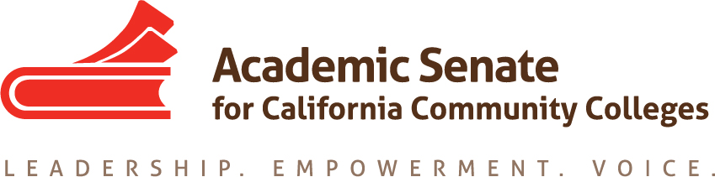

Curriculum Committee Meeting

Date: Tuesday, 18 October 2016

8:30 AM – 10:00 AM

CCC Confer

Passcode: 528816

1-719-785-4469 or

1-888-450-4821

AGENDA

- Call to Order and note taker
- Discussion items, with action as needed
  - Curriculum Regionals – 21 and 22 October -- Skyline and Mt. SAC
      - Attendees – Michael Wyly and Randy (north); everyone except Michael Wyly in south
      - PPTs
      - Logistics
  - Curriculum Paper on Course Outlines of Record
    - Outline approved by the ASCCC Executive committee (attached)
    - Timelines
  - Curriculum Institute – 12-15 July 2017 in Riverside
    - All members expected to attend and present
    - Anticipating 700 people in attendance this year
    - Will need to begin planning with first draft of agenda due in March
  - Meeting Schedule
    - 15 November, 8:30 – 10am
    - 6 December, 8:30 – 10am
    - 17 January, 8:30 – 10am
    - 25 February, 10-3, Mt. SAC
    - 21 March, 8:30 – 10am
    - 18 April, 8:30 – 10am
    - 6 May, 10-3, Los Angeles Valley

- Announcements
  - Upcoming Events:
    - Curriculum Regionals, 21-22 October 2016
    - Formerly Incarcerated Students regionals – 21 October 2016, 18 and 19 November
    - Minimum Qualifications and Equivalencies Regionals – 28 October (Woodland)
    - Executive Committee Meeting, Wednesday 2 November 2016, Westin South Coast Plaza
    - ASCCC Fall Plenary Session, Thursday – Saturday, 3-5 November 2016, Westin South Coast Plaza
  - Other announcements?
- Adjournment

