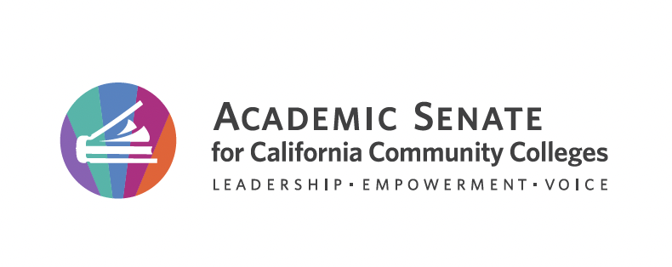
The Stanback-Stroud Diversity Award Application
Each response is limited to 200 words per prompt (including supplemental support or evidence)

Describe your efforts to create an inclusive and supportive campus climate.
Supplemental Support or Evidence (included in the 200 word limit):

What effective teaching and learning strategies have you implemented?
Supplemental Support or Evidence (included in the 200 word limit):

Describe activities that have facilitated student access, retention, and success.
Supplemental Support or Evidence (included in the 200 word limit):

Describe activities that have fostered student engagement in campus life.
Supplemental Support or Evidence (included in the 200 word limit):

Nomination documents

