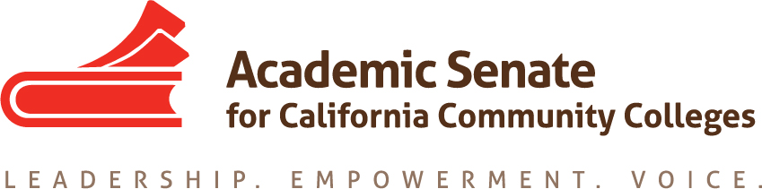

Equity and Diversity Action Committee

20 September 2017

10:30-3pm

Chair’s House, San Jose, CA

AGENDA

- Call to Order and Adoption of the Agenda

- Application for Statewide Service – http://asccc.org/content/application-statewide-service

- EDAC Regionals
  - Specifics
    - 27 October at Solano
    - 28 October at Fullerton
    - Participation of committee members
  - General Session Focus on Civil Discourse
  - Topics for breakout sessions
  - Other logistics for sessions

- Plenary Planning
  - Breakout of Civil Discourse
  - Breakout to report current activities/other ideas
- Other assignments to EDAC

- Announcements
  - Events
- Executive Committee Meeting, 29-30 September, Moreno Valley College
- Fall Area Meetings – 13 and 14 October, locations vary
- CTE Regional Meetings – 20 and 21 October
- EDAC Regionals – 27 and 28 October
- Fall Plenary Session – 2-4 November, Irvine Marriott
- Curriculum Regionals – 17 and 18 November

- Additional Announcements/Issues
- Adjournment

