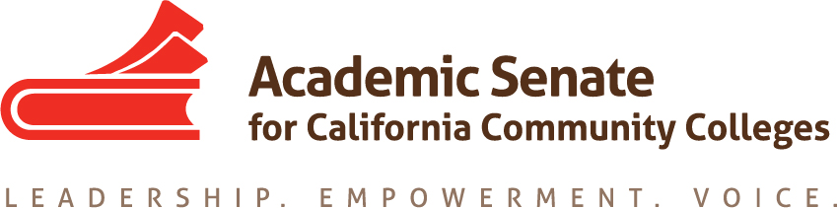

Equity and Diversity Action Committee Meeting

25 August 2017, 9-10am

CCC Confer
Participant Passcode: 955961

Toll free number available: 888-450-4821

AGENDA

- Call to Order and Adoption of the Agenda

- Introductions

- Planned in-person meeting for September
  - Possible dates
  - Location
  - Travel Logistics
  - Other?
- Topics
  - EDAC Regionals on Civil Discourse (initial draft attached) – 27-28 October 2017
    - North and South
      - North = Solano College? Other?
      - South = Fullerton College
  - Breakout session topics
  - Other foci for general sessions
  - Speakers/possible topics?

- Other priorities this year
  - Email attachment

- Other Items for Discussion

- Announcements/Events
  - OER Regional Meetings – 15 and 16 September
  - CTE Regional Meetings – 22 and 23 September
  - Fall Area Meetings – 13 and 14 October, locations vary
  - Fall Plenary Session – 2-4 November, Irvine Marriott

- Adjournment

