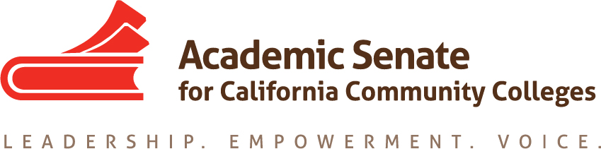

ASCCC Diversity, Equity and Action Committee (EDAC)

Wednesday December 19, 2018

8:00 A.M. – 10:00 A.M.
Location: Zoom/CC Confer

8:00 A.M. – 8:15 A.M.

- Order of the Agenda
- Roll Call/Membership Review/Welcome New Member (Sandy Somo)*

EDAC Membership List - (2018 - 2019)

Silvester Henderson, Chair - Los Medanos College - Area B
Conan McKay - Chair (2nd) - Medocino College - Area B
Robin Allyn - Mira Costa College - Area D
Leigh Ann Shaw - Skyline College - Area B
Sandy Somo – Glendale College – Area C* (Recently Appointed)
Khalid White - San Jose College - Area B
Carlos Lopez - Folsom Lake College - Area A
Nathaniel Donahue - Santa Monica College - Area C

- Review of the Minutes from 10-26-2018 Meeting
- EDAC Four Priorities: Review

- Faculty Diversity & Hiring (I)
- Student Equity, Student Services & Support (II)
- Research & Academic Guides for Equitable Student Success (III)
- Pathways to College Teaching – A2MEND/Continued Business (IV)

(8:15 A.M. – 8:45 A.M.)

5. EDAC Priorities:

Area I – (15 Minutes)
“Faculty Diversity Hiring & System Partnerships”
Update Status Report:

I
“IEPI Buidling Diversity Hiring Summit”
Date: 2/8/2019 – 2/9/2019
Location/Time: Gateway Los Angeles Hotel
6101 W. Century Boulevard
Los Angeles, CA 90045
EDAC Outcomes: Breakout Suggestions from EDAC/FDC to the ASCCC President
(See Breakout Attachments Submitted to State Chancellor’s Office – Six)

II

ASCCC Hiring Regionals (Three) – (15 Minutes)
10:00 A.M – 3:00 A.M.
February 21, 2019 – Bakersfield College (Area A)
February 25, 2018 – Yuba College (Area A)
February 28, 2018 – Norco College (Area D)
EDAC Outcomes: Breakout Suggestions from EDAC/FDC Joint Planning Meeting scheduled for
November 29, 2018 – Sacramento City College – 2:00 P.M. – 6:00 P.M.
A: See Attached Proposed Program Agenda & Presenters (Created from Joint Meeting)
B: Discuss Travel & Hotel Accommodation Concerns/Please Discuss/Emails Sent!

(8:45 A.M – 9:15 A.M.)
Area II – 30 Minutes/5 Minutes Each
“Student Equity, Student Services & Support”
Update Status Report:

I

“LGBTQIA”– Expanded Support
Nate/Conan – Rostrum Article – Pride Month – Discussion /Update
A: Submission Date

“DACA Expanded Support”
Leigh Ann/Carlos - Rostrum Articles - Plenary Breakouts (Sp19) – Discussion/Update
A: “What is being done and what is not being done regarding DACA
B: “ Possible “Breakout” topic for the Spring ASCCC Plenary (TBD)
“Student Safety & Support/Sexual Assault”
Silvester – Chancellors Office – Emailed 10-21-2018 – Discussion/Update
A: Peter Chang – Deputy Counsel Response November 2, 2018
(See Attached Letters/Email Request)
“Inmate Education”
Silvester – Chancellors Office/Update - Discussion
A: Trailer Bill 1809
B: Currently and Formerly Incarcerated Students Reentry Program Grants Information
(See Attached) - Application Due: 1-31-2019

ASCCC/EDAC – Prison Visit
A: EDAC Chair - “Cal City Correctional Institute” – Reschedule (TBA)
B: Spring Plenary Breakout – “Prison Education Programs & Performing Arts”

(9:15 am – 9:35 am)

Area III – 20 Minutes
“Research & Academic Guides for Equitable Student Success” (III)
Update Status Report:

I
A: Student Equity Plan Outline & Original Attached
Assigned Persons/Areas – Review
B: ASCCC Executive Members Suggestions
The Executive Committee reviewed the outline for updating the ASCCC Student Equity Plan Paper.
The committee recommended the following:

- Include additional student groups such as the following: veterans and those with disabilities.
- It was recommended to include a caveat (explanation) indicating that the “Student Equity and Achievement Plan” is designed to serve all underrepresented students.
- It was suggested to use “developmental education reform” or “student capacity and support needs” instead of AB 705 as a section title.
- Outline Accepted & Approved with above suggestions & modifications on October 31, 2018.
C: Chair Suggestions:– Major Focus – Writing Day – January Meeting (Three - Four Hours)
Contact/Location: Carlos Lopez (TBA)
(9:35 am – 9:45 am.)
Area IV (15 Minutes)
Pathways to College Teaching – A2MEND (IV)
Update Status Report:

I
A2MEND – Partnership Presentation (March 2019)
A: (Silvester - EDAC Chair has been asked to communicate with A2MEND Leaders.
B: See Attached Emails/Discuss Next Steps to be taken!

II

New/Continuted Business (10 Minutes)
Update Status Report
A: Education Code 87408 (See Attachments)
B: Possible Resolution – Spring Plenary (Leigh Ann/Richard Weinroth)
(9:55 am – 10:00 am.)
6. Future Meeting Dates:
January 16, 2019 (All Day/Face to Face) - Los Rios District/TBA
Contact Person – Carlos Lopez (Confirm by Email)
January 31, 2019 (Zoom) 1:00 P.M. – 3:00 P.M.
7. Closing Comments - Happy Holidays EDAC Committee – Lets Stay Together & Love Each!

