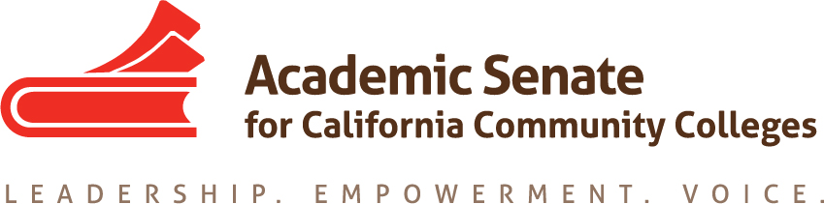

Equity and Diversity Action Committee

16 March 2018, 10am-3pm

Fullerton College 321 E. Chapman Avenue, Fullerton, CA

Building #400, room #439 (3rd floor)

http://www.fullcoll.edu/sites/all/userfiles/FC%20SUMMER%202018%20Map.pdf

AGENDA

- Call to Order and Adoption of the Agenda, Notetaker

Call to Order and Agenda Adopted at 10:02 AM
Notes submitted by Michael Wyly, 3.16.2018
Members Present: Dolores Davison (chair), Sam Foster (second), Eartha Johnson, Orlando Shannon, Michael Wyly

- Status of Previous Action Items
  - DACA letter and resources

Letter submitted via ICAS meeting (Feb) to UC and CSU to ask after access to DACA resources for all students, regardless of system, CCC, CSU and UC. All three systems have expressed interest in developing shared resources for DACA/Dreamers. The League is also interested in helping to create a resource document to advise faculty at the local level in how to support DACA students—initial statement/resources under development.

Recent legal opinion for how ICE may access community colleges and its students, including single point of absence and requirements for a warrant. Colleges to hold harmless students impacted to access by ICE, including incompletes and Excused Withdrawal. Suggestion to provide guidance for local colleges to define conditions for EW. Question: how best to connect EW to prior conversations re: disenfranchised students: to compile a list of conditions? To recommend local procedures? How to connect to early alert systems? How to advise local senates? Possible Rostrum article—Dolores to check with CCCCC and Exec to advise.

SB 183 (Lara) making its way through the process: if passed, would further restrict ICE agents, including access to public buildings/spaces.

  - EEO Committee Update

CCCCO budget to include $2.76m augment (~$50k per complying district) for EEO fund, including compliance with identified multiple methods (including the establishment of the EEO committee and adhering to eight identified methods). Colleges to have some sort of EEO program, including a required EEO committee, to increase diversity in hiring. Colleges to show compliance with six of the eight identified methods. Incorporation of how to use longitudinal data re: hiring, including regional trainings for local research Discussion of various training approaches across the State, as well as how to connect research and planning to human resources at the local level. 3-4 projected events through IEPI through the next year. Also: updates via the PLN, creation of an EEO resource page, video training and forthcoming hiring pipeline project for how to connect graduate schools to community colleges, including more remote colleges. Discussion of best practices for discipline-specific outreach to CSU/UC graduate schools, including mentorship and apprenticeships, and recent outreach to STEM graduates.

  - Faculty Hiring Paper

Incorporated suggestions from February Executive Committee meeting. March Executive Committee review included additional suggested changes. Revised paper to go before the Body at S 2018 Plenary.

- EDAC Regionals
  - North at Woodland College, 6 April 2018, 10-3

  - South at Southwestern College, 7 April 2018, 10-3
    - Who will be in attendance
    - Breakouts
    - Travel

Both sessions to follow the same format/selection of topics: Intro/welcome. Update by reps from EEO Advisory Committee (Davison, Foster, and Knapp) to include discussion of hiring and diversity for general session: current state of affairs, including presentation of data; discussion of identified measures for EEO. For breakouts—(1) new info/data/updates pertaining to DACA, including DACA resources; (2) how to serve under-represented students, including EW grade and relevant Title 5 language, and strategies for implementation; additional/new/forthcoming resources for DACA support; and strategies for disenfranchised students. (Consensus: if there are too few enrollees for breakouts, separate breakouts to become additional general sessions per Fall 2017 EDAC Regionals.)

Discussion of support for incarcerated students and how current work, including the current pilot, is of relevance to EDAC Regionals (items listed above) and Plenary presentations (items listed below).

- Plenary Planning – 11-14 April 2018, San Mateo Marriott
  - Breakout on Gender Issues – Eartha/Michael/Dolores

  - Breakout on Incarcerated Students – Dolores/Michael/Sam/Orlando

  - Breakout on Faculty Hiring – Dolores/Jake/Michael?

Breakout descriptions and related topics discussed, including roles of presenters, presentations organization, and applicable resources. Leads assigned for initial drafts of presentations.

- Future Topics
  - Update of paper https://www.asccc.org/resolutions/revise-2002-paper-student-equity-guidelines-developing-plan

Discussion of Equity Guidelines paper: do we outline the paper for next year’s committee? Consensus is to review prior paper and to make recommendations to the next committee in lieu of a formal outline.

  - Speakers/general session for Academic Academy: September 14-15 @ Hilton SF Airport Bayfront.

Suggestions for speakers. Possible presentation of how to address equity gaps as part of Guided Pathways and AB 705 implementation: faculty forward, senate-led model(s).

- Announcements
  - Area Meetings, 23-24 March 2018
  - Career and Noncredit Education Institute, 3-5 May, Westin South Coast Plaza
  - Guided Pathways Regionals, 11-12 May (Locations TBD)
  - Curriculum Regional Meetings, 18-19 May (TBD/LATTC)
  - Faculty Leadership Institute, 14-16 June, Sheraton Park Anaheim
  - Curriculum Institute, 11-14 July, Riverside Convention Center
  - Part-Time Faculty Institute, 2-4 August, Westin SFO

- Application for Statewide Service for next year – http://asccc.org/content/application-statewide-service
  - Dolores encouraged all committee members to submit applications for next year

- Adjournment – 3:05pm

