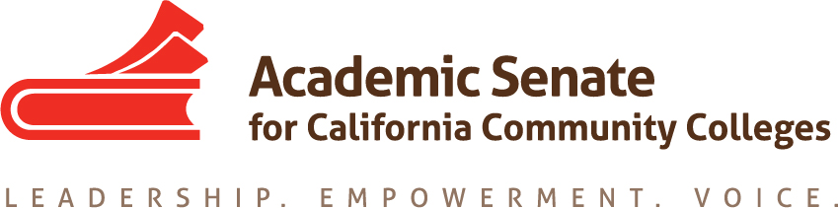

Educational Policies Committee

Friday, 13 May 2016

10:00 AM – 11:00 AM

CCC Confer: 1-888-886-3951
Participant Pin:
951568

MINUTES

- Call to Order

- Approval of the Agenda
  - Approved
  - Members present: Lillian Batista-Edwards, Julie Bruno, Tonya Cobb, Dolores Davison, Jason Edington, Corinna Evett, Cynthia Reiss
  - Members absent: Olivia Light, Wheeler North

- Discussion items, with action as needed

  - Plenary Breakout report
    - Ed Policies folks did a breakout on dual enrollment. Without the toolkit, the breakout needed to be revised a few days before the presentation. The Plenary Plague attacked Jason, so Dolores and Cynthia valiantly carried on with the presentation.
    - Presentation focused quite a bit on basic skills.
    - Much interest in dual enrollment evidenced by the number of attendees.
  - Dual Enrollment Task Force
    - It was interesting because the dual enrolment toolkit is still not out yet.
    - Almost a month since plenary and still no toolkit.
    - New plan to release different components of resources related to dual enrollment at different times:
      - Now set to put out a FAQ document before releasing the toolkit.
        - Because faculty weren’t involved in the creation of the document, the FAQs need to be revised, such as a section about colleges setting minimum qualifications, and faculty evaluations.
        - Hope to have the first iteration of the FAQ document (so far 31 pages with widespread research) released by the end of May.
    - Some colleges already actively participating in dual enrollment while faculty at other colleges are asking their administrators to slow down before jumping into dual enrollment agreements.
    - The FAQ article in the fall Rostrum really sparked interest and discussion. Central message: Include faculty in dual enrollment discussions.
  - Actions moving forward
    - Once it’s out, the committee will want to continue work with/discussions of the toolkit.
    - Resolution regarding creating a document related to academic integrity may be something to consider in the future since we were unable to get to it this year.
    - Dolores will meet with the new Ed Pol Chair Ginni May to help with the transition for next year’s committee.
    - Dolores expressed appreciation and thanks to the committee members for their efforts this year.
    - Committee members expressed thanks to Dolores for her excellent leadership and to the other committee members for the positive experience and opportunity.
  - Next year’s committee service: http://www.asccc.org/content/application-statewide-service
    - Need to fill out the application again if you want to serve, and Dolores and Julie encouraged the committee to sign-up again to serve.
    - Encouraged the committee members to list more than one area of interest.
    - Dolores mentioned that she would provide positive recommendations for any members who wish to serve on a committee next year.

- Announcements
  - Faculty Leadership: June 10-12, Mission Inn, Riverside
  - Curriculum Institute July 7-9, Anaheim Doubletree

- Adjournment
  - Many wishes for a successful remainder of the semester!

