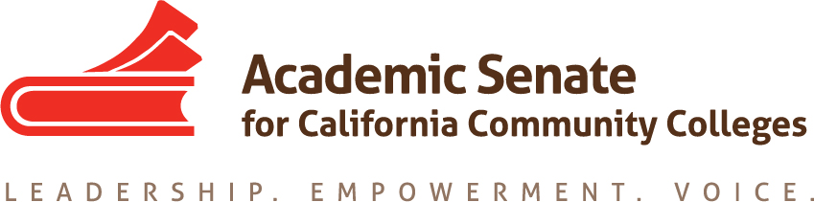

FACULTY DEVELOPMENT COMMITTEE

Wednesday, November 21, 2018

8:00-9:30 AM

Meeting Notes

- Call to Order and Adoption of the Agenda
- Member Roll Call
Michele Bean Mayra Cruz
Carolyn Holcroft Rebecca Eikey
Elizabeth Imhof LaTonya Parker
Manjit(Manny) Kang

- Approval of 10/19 Minutes – approved by consensus.

- Review Work Plan and Assignments
https://drive.google.com/drive/folders/1GIHzQfQh0jiPQGZ8Jnc0Md545jODKudn
2.1A Lead professional development opportunities designed to promote recruitment of diverse faculty
Meeting is planned next week with EDAC to work on the hiring regionals.

2.1C Design leadership development opportunities focused on specific populations of faculty
No update on the women’s circle.

2.2B Develop and strengthen partnerships with organizations that specifically serve racially/ethnically diverse populations and recruit members to serve in ASCCC committees
Update on the UMOJA/A2MEND Educational summit was provided. The work plan was updated to include “recruit members to serve in ASCCC committees” and perhaps there could be intentional collaboration/recruitment with UMOJA/A2MEND leaders.

3.2 A. Implement a comprehensive ASCCC Professional Development Plan
Update provided on Guided Pathways Taskforce and communication related to professional development. The Chancellor’s Office is interested in taking the lead on professional development with Guided Pathways. There will be more conversation related to developing improved partnership with ASCCC and the Chancellor’s Office.

- Update on Status of Committee Priorities for 18-19
https://docs.google.com/spreadsheets/d/16LxdTXnuPX8WUI8n0yPuQZSCARSDD72TTEk5g4xZLR8/edit#gid=296631368
a. Rostrum articles update
i. Information to local senate leaders regarding faculty professional development and its role at their colleges; rights and responsibilities for involvement in the development of faculty professional development policies, including the use of potential funding provided by AB 2558 (Williams, 2014) (Lead: Carolyn Holcroft)
Carolyn will be taking the lead on the development of the rostrum article. AB 2558 (Williams, 2014) was not funded. Carolyn will draft an outline of the article to include role of academic senate and use of funds.
- Assert to statewide initiative leaders the importance of respecting the purview of the Academic Senate and local senates regarding faculty professional development; California Community Colleges work with the Chancellor’s Office and other system partners to ensure that the Board of Governors’ Standing Orders are respected and that all future assignments in the area of faculty professional development involve input and affirmation from the Academic Senate and local senates
Will be discussed at next meeting.

b. Hiring priorities criteria survey and proposed timeline draft
The survey was updated to include additional questions and criteria. It will be submitted to ASCCC Executive committee for December 7/8 meeting.

- Status of Previous Action Items
See below on page 3.

- Fall 2018 Plenary Report/Resolutions
https://www.asccc.org/events/2018-11-01-150000-2018-11-03-210000/2018-fall-plenary-session
The final resolution packet has been uploaded to ASCCC website.

VIII. ASCCC Spring 2019 Hiring Regionals and CCC/IEPI Building Diversity Summit

November 29th Joint Planning Meeting with the Equity & Diversity Action Committee
2-6pm, Sacramento City College Rodda Hall North (RHN) 258
An agenda is developed and a list of potential topics and speakers is being developed for the Regionals.
For the IEPI Summit, there are a number of committee members interested in being part of the Summit in February. Mayra is working with ASCCC office to determine how many members can attend. There are also members of EDAC who are interested in attending. A submission form is due November 30th.

IX. Announcements
- Upcoming Committee Meetings
December 5, 2918 8:00-9:30am
Faculty Development Committee Meeting
ZOOM
- Upcoming ASCCC Events
https://asccc.org/calendar/list/events
c) Application for Statewide Service
http://asccc.org/content/application-statewide-service
d) On Dec 19, Santa Barbara City College is hosting their Affective Learning Institute and members of the committee are invited.

X. Committee Meeting Calendar
  - January 22nd 8-9:30am
  - Feb & March 2019- TBA

XI. Adjournment

Status of Previous Action Items

- In Progress (include details about pending items such as resolutions, papers, Rostrums, etc.)
- Rostrum article #1
- Faculty Diversification Hiring Regionals & CCC/IEPI Building Diversity Summit planning
- Women’s Leadership Circle

B. Completed (include a list of those items that have been completed as a way to build the end of year report).
- 2019 Faculty Development Work Plan
- Hiring Priority Criteria Survey (11/21/18)

The Faculty Development Committee creates resources to assist local academic senates to develop and implement policies that ensure faculty primacy in faculty professional development. The committee assess the Academic Senate’s professional development offerings and makes recommendations to the Executive Committee on policies and practices for faculty professional development at a statewide level and on the development of new faculty professional development resources to ensure effectiveness and broader access and participation. Through the Professional Development College, the committee supports local faculty development and provides guidance to enhance faculty participation in the areas of faculty development policies, community college faculty professionalism, innovations in teaching and learning, and other topics related to academic and professional matters. The committee advocates for the importance of faculty development activities related to student success, quality faculty teaching and learning, academic and professional matters, and for appropriate levels of funding for such activities. https://www.asccc.org/directory/faculty-development-committee-1

