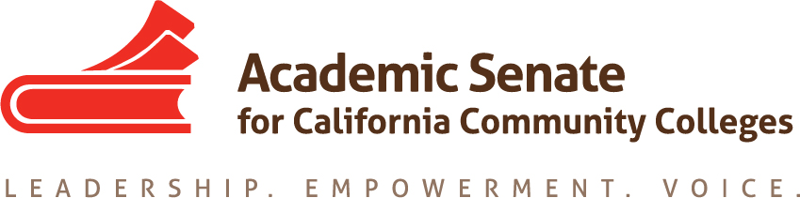

Faculty Development Committee

Saturday September 26th, 2015

9:30 AM – 2:00 PM

West Los Angeles College

Members Present: J. Adams, A. Foster, K. Oborn, C. Rutan, K. Schaefers

- Order of the Agenda: Agenda was approved as presented.
- Minutes from the August 16, 2015 meeting were approved as presented.
- Clarification of the Charge of the Committee:
The committee discussed the new committee charge. The newly approved charge of the committee is:
The Faculty Development Committee creates resources to assist local academic senates to develop and implement policies that ensure faculty primacy in faculty professional development. The committee assess the Academic Senate’s professional development offerings and makes recommendations to the Executive Committee on policies and practices for faculty professional development at a statewide level and on the development of new faculty professional development resources to ensure effectiveness and broader access and participation. Through the Professional Development College, the committee supports local faculty development and provides guidance to enhance faculty participation in the areas of faculty development policies, community college faculty professionalism, innovations in teaching and learning, and other topics related to academic and professional matters. The committee advocates for the importance of faculty development activities related to student success, quality faculty teaching and learning, academic and professional matters, and for appropriate levels of funding for such activities.

The new charge emphasizes that the committee is focused on statewide issues related to faculty professional development. The committee will focus on identifying issues that affect all colleges, creating a professional development plan for the ASCCC, evaluating the professional development offerings of the ASCCC, and suggesting additional professional development options for ASCCC and the Professional Development College (PDC)

- ASCCC Professional Development Plan
The Executive Committee has tasked the FDC with developing a professional development plan for the Academic Senate. The plan needs to be tied to the ASCCC’s Strategic Plan that was adopted at the Spring 2015 Plenary Session. Areas proposed for the plan include strategies to recruit diverse faculty locally and for statewide service, evaluation of current ASCCC professional development offerings, explore new options for ASCCC professional development beyond regional meetings, institutes, and plenary sessions, developing new modules for the PDC, exploration of partnerships with other groups like the Institutional Effectiveness Partnership Initiative (IEPI), and propose strategies to position the ASCCC as the leader for community college faculty professional development. C. Rutan will compile the ideas shared at the meeting into a preliminary draft for the committee to work on at the next meeting.

- Strategies to Assess Effectiveness of ASCCC Professional Development Events
The ASCCC sends out surveys following each professional development event to all attendees. J. Adams reported that very few surveys are completed and the majority of the responses focus on things that the senate does not control like the quality of the food or the temperature in breakout rooms. In order to make the surveys more effective, the committee discussed having outcomes for each session that would be listed in the online program. A possible template for breakout descriptions was suggested. The template would include 1) issue/context (resolutions, legislative update, CCCCO priorities, etc.) 2) content of session, and 3) expected outcome/take-away from the session. That would help orient attendees as well as ensure that presenters are equally mindful of outcomes for attendees. There was also discussion about including overall outcomes for events to help market them. This would be particularly helpful when creating new events like the Instructional Design and Innovation (IDI) Institute. C. Rutan will bring this idea to the November Executive Committee meeting and if it is approved, the IDI will be the first ASCCC event to include outcomes.

- Discuss Possible Future Topics for the Professional Development College (PDC)
C. Rutan and J. Adams presented the plan for the PDC to include modules that interested faculty would be able to access at any time. The first module will be the recently completed Curriculum Basics 101 that is being prepared by the vendor for final posting. The committee discussed several possible modules that could be developed. The suggested modules were:

- Rights and Responsibilities of Academic Senates
- Laws and Regulations Governing Public Groups: Brown Act and Robert’s Rules of Order
- Minimum Qualification and Equivalencies
- Inmate Education
- Being an Academic Leader
- Improving Collaboration and Inclusivity through Better Communication
- Hiring of Diverse Faculty
- Community College Budgets
- Pertinent and Relevant Sections of Title 5 and Education Code
- The History, Mission, and Goals of the ASCCC

A partial list of these possible topics will be brought forward to the November Executive Committee meeting for discussion. Additional modules will continue to be discussed by the committee and a list of possible modules will be included in the draft professional development plan.

- Discussion of Fall Plenary Breakout
The FDC has one breakout at Fall Plenary. The breakout will include a discussion with the audience about the effectiveness of ASCCC at meeting their PD needs. The breakout will also include a discussion of new ways of offering professional development other than an in person presentation. These methods will include the modules of the PDC, webinars, podcasts, and recording ASCCC presentations and posting them to the web. K. Oborn and K. Schaefers will both join C. Rutan and J. Adams at the presentation. In addition to the presentation, members of the FDC will be asked about to provide feedback on the sessions that they attend at the FDC meeting following the plenary session.
- Scheduling Future Meetings
The next FDC meeting will be on October 29, 2015 from 10 AM until 12 PM via Zoom. C. Rutan will send out an agenda and login information for the meeting.

The meeting adjourned at 1:40 PM

Respectfully Submitted,

Craig Rutan

