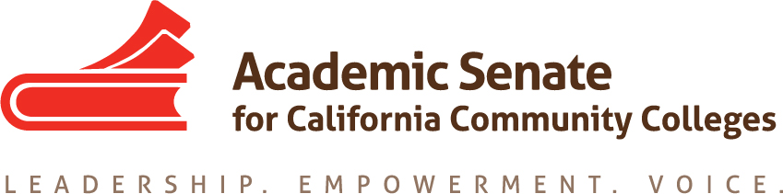

Faculty Leadership Development Committee
Thursday, April 23, 2020
3:00 p.m.—4:30 p.m.

ZOOM INFO:
Join from PC, Mac, Linux, iOS or Android: https://cccconfer.zoom.us/j/93723639768
Or iPhone one-tap (US Toll): +16699006833,93723639768# or +13462487799,93723639768#
Or Telephone Dial:
+1 669 900 6833 (US Toll)
+1 346 248 7799 (US Toll)
+1 253 215 8782 (US Toll)
+1 301 715 8592 (US Toll)
+1 312 626 6799 (US Toll)
+1 646 876 9923 (US Toll)
Meeting ID: 937 2363 9768

AGENDA
The Faculty Leadership Development Committee creates resources to assist local academic senates in the development and implementation of policies that ensure faculty primacy in faculty leadership and professional development. The committee assesses the Academic Senate’s professional development offerings and makes recommendations to the Executive Committee on policies and practices for faculty professional and leadership development activities at a statewide level. The committee supports local faculty development and provides guidance to enhance faculty participation in the areas of faculty development policies; faculty professionalism and leadership development; innovations in teaching and learning; and other topics related to academic and professional matters. The committee advocates for funding, resource allocation, and a commitment to faculty development activities focused on equity-minded practices and student success.

- Roll Call, Call to Order, and Agenda Adoption

Michelle Bean—Chair
Sam Foster—2nd Chair

Elizabeth Day
Elizabeth Imhof
Christy Karau
Luke Lara
Emilie Mitchell

- Minutes Volunteer

- March Minutes

- Lean-In and Check-In

- Faculty Diversification Work
  - CCCCO Diversity Symposium was March 20—possibly rescheduled for October
  - ASCCC Professional Development Series—webinar (April 8) and follow-up (April 10) on Hiring in Virtual Environment (Lara, Bean, Cruz, Raphael)
  - Model Hiring Processes and Guiding Principles Zoom meeting with ACHRO, CIO, and CSSO Representatives recap (March 30)
  - Review missing components in our Model Hiring grid
    - Added Equivalency #3b—need components
    - Criteria for adding tools and resources
  - Canvas shell
    - Layout of content
    - Outcomes and assessments for PDC?
    - CSU Credit? Badges?
    - Other recommendations

- Anti-Racism Work
  - ASCCC Professional Development Series—webinar on Opportunities for Positive Structural Change in This Crisis (April 24 w/Imhof, Buul, Cruz, Lara)
  - Rostrum article (Imhof and Buul)

- Faculty Empowerment and Leadership Academy (FELA) Next Steps
  - CSU Credit COR and Form (Imhof and Bean)
  - Mentor Handbook (Mitchell, Day, Bean)

- Faculty of Color Leadership Opportunity Survey—due date extended to fall 2020

- Umoja/A2MEND Leg Day
  - Wednesday, April 22 Town Hall #BlackStudentSuccess
  - Webinar Series and Advocacy Letter

- FLDC June Meeting
  - Faculty Leadership Institute—virtual webinar style
  - FLDC meeting change to June 11?

- Announcements
  - Check for upcoming events at https://asccc.org/calendar/list/events
- Electronic Elections—April 27 to May 15 (3 rounds in eBallots)
  - Full list of winners announced May 18
  - Special Elections if needed May 25
- President’s Report
  - PD Series: 3,500+ participants
  - Guidance Memos—14 w/CCCCO
  - Transfer focus for fair treatment w/system partners
  - Distancing until August—SCFF concerns
  - ASCCC finances good
  - Possible virtual Leadership Institute—virtual event fees
  - Ways to help during COVID-19
    - Join Amazon Smile—find ASCCC Foundation
    - Give to Relief and Recovery Campaign at Foundation for CCC
  - Application for Statewide Service

- Closing Comments and Reflections
  - Next meeting: May 21 at 3:00—4:30 p.m.
  - In-Progress and Completed Tasks review
  - Any other final comments or suggestions?

- Adjournment

In Progress:
- Hiring Guiding Principles and Model Practices Canvas Shell
- Part 2: Anti-Racism Hiring Practices Rostrum article
- Umoja/A2MEND Virtual Town Hall Leg Day planning/communication
- FELA Course Outline of Record

Completed Tasks:
- ASCCC Event Survey Questions on Gender, Race, Ethnicity
- Faculty Leadership Survey Questions for Faculty of Color (Reminder: Distribute in fall 2020)
- Faculty Empowerment and Leadership Academy (FELA) Framework and Applications (Reminder: Market in fall 2020 for spring 2021)
- Rostrum article: Womyn’s Survey
- Rostrum article: Anti-Racism
- Rostrum article: Caucus Structure
- Rostrum article: Sex, Gender, Race, and Economic Disadvantage: Courageous Conversations About Intersectionality
- Rostrum article: Equitizing Merit and Fit: Establishing a Baseline Understanding
- Collaborations—chair meet with Puente directors on October 30, attended Umoja Education Summit October 31, CCC LGBTQIA+ Summit 2019 panelist
- Updated the FLDC charge/description
- Rostrum article: Convergence of Diversity and Equity: Guiding Principles for Hiring Processes
- A2Mend Collaboration—A2Mend board members presented at 2019 ASCCC Academic Academy
- Umoja/A2Mend—chair completed workgroup meetings for Black Student Report Card for CCCs
- Womyn’s Leadership Survey distributed in September

