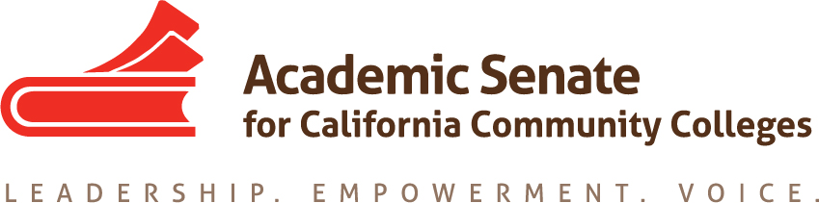

Faculty Leadership Development Committee
Thursday, May 21, 2020
3:00 p.m.—4:30 p.m.

ZOOM INFO:
Join from PC, Mac, Linux, iOS or Android: https://cccconfer.zoom.us/j/96717481505
Or iPhone one-tap (US Toll): +16699006833,96717481505# or +13462487799,96717481505#
Or Telephone Dial:+1 669 900 6833 (US Toll)
Meeting ID: 967 1748 1505

AGENDA
The Faculty Leadership Development Committee creates resources to assist local academic senates in the development and implementation of policies that ensure faculty primacy in faculty leadership and professional development. The committee assesses the Academic Senate’s professional development offerings and makes recommendations to the Executive Committee on policies and practices for faculty professional and leadership development activities at a statewide level. The committee supports local faculty development and provides guidance to enhance faculty participation in the areas of faculty development policies; faculty professionalism and leadership development; innovations in teaching and learning; and other topics related to academic and professional matters. The committee advocates for funding, resource allocation, and a commitment to faculty development activities focused on equity-minded practices and student success.

- Roll Call, Call to Order, and Agenda Adoption

Michelle Bean—Chair
Sam Foster—2nd Chair

Elizabeth Day
Elizabeth Imhof
Christy Karau
Luke Lara
Emilie Mitchell

- Minutes Volunteer

- April Minutes

- Lean-In and Check-In

- Faculty Diversification Work
  - CCCCO DEI Report 2020
  - FON—no suspension, just no penalty. July BoG meeting—will address next year’s requirements.
  - Prop 209 ACA 5 (constitutional amendment)—Exec voted to support repeal of section 31 of ACA 5; Leg and Advocacy Chair will craft and send letter to legislators.
  - Model Hiring Processes and Guiding Principles Zoom meeting with ACHRO, CIO, and CSSO Representatives vet Canvas shell on May 27.
  - Review our Model Hiring grid
    - Canvas shell
    - Missing tools and resources
    - Other recommendations?

- End-of-Year Reports
  - Review document
  - Update Committees Priority sheet

- Anti-Racism Work
  - ASCCC Professional Development Series—webinar on Opportunities for Positive Structural Change in This Crisis
  - African-American Student Success Week webinars and Virtual Town Hall with Umoja/A2MEND and legislators—1,114 attendees at Town Hall.
  - Latinx Town Hall organized by Colegas and CCCCO—790 attendees.
  - Rostrum article (Imhof and Buul) –on pause till fall.

- Faculty Empowerment and Leadership Academy (FELA) Next Steps—paused till next year.
  - FELA webpage went live (May 2020) and info shared in ASCCC newsletter
  - Budget Line Item--$10,000 for 2020/2021
  - Still to compete:
    - CSU Credit COR and Form
    - Mentor Handbook

- Faculty of Color Leadership Opportunity Survey
  - Due date extended to fall 2020
  - Survey sent in March to the following:

- SP Listserv
- Ethnic Studies Listserv
- Women Studies Listserv
- Puente - to EDs Allsopp and Vergara
- Umoja - to their communications staffer
- A2MEND - to Dr. Bush
- APAHE - to President Ali
- Latina Leadership Network - President Dr. Gomez de Torres
- LGBTQIA+ Caucus Members
- Liaison List
- CCLC - to Agnes
- Deputy Chancellor Dr. Gonzales

- Announcements
  - Check for upcoming events at https://asccc.org/calendar/list/events
- Electronic Elections—April 27 to May 15 (3 rounds in eBallots)
  - Full list of winners announced May 18
  - Special Elections if needed May 25
- President’s Report
  - Ways to help during COVID-19
    - Join Amazon Smile—find ASCCC Foundation
    - Give to Relief and Recovery Campaign at Foundation for CCC
  - Application for Statewide Service—complete by end of May and forward to colleagues!

- Closing Comments and Reflections
  - June 11 meeting
  - Any other final comments or suggestions?

- Adjournment

In Progress:
- Hiring Guiding Principles and Model Practices Canvas Shell—need tools and resources sections.
- Part 2: Anti-Racism Hiring Practices Rostrum article—paused till next year.
- FELA Course Outline of Record—paused till next year.

Completed Tasks:
- Umoja/A2MEND Virtual Town Hall Leg Day planning/communication
- ASCCC Event Survey Questions on Gender, Race, Ethnicity
- Faculty Leadership Survey Questions for Faculty of Color (Reminder: Address results in fall 2020)
- Faculty Empowerment and Leadership Academy (FELA) Framework and Applications (Reminder: Market in fall 2020 for spring 2021)
- Rostrum article: Womyn’s Survey
- Rostrum article: Anti-Racism
- Rostrum article: Caucus Structure
- Rostrum article: Sex, Gender, Race, and Economic Disadvantage: Courageous Conversations About Intersectionality
- Rostrum article: Equitizing Merit and Fit: Establishing a Baseline Understanding
- Collaborations—chair meet with Puente directors on October 30, attended Umoja Education Summit October 31, CCC LGBTQIA+ Summit 2019 panelist
- Updated the FLDC charge/description
- Rostrum article: Convergence of Diversity and Equity: Guiding Principles for Hiring Processes
- A2Mend Collaboration—A2Mend board members presented at 2019 ASCCC Academic Academy
- Umoja/A2Mend—chair completed workgroup meetings for Black Student Report Card for CCCs
- Womyn’s Leadership Survey distributed in September

