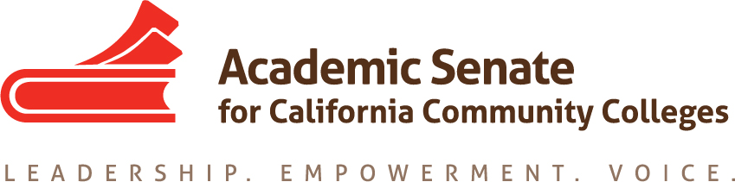

Faculty Leadership Development Committee
Thursday, October 17, 2019
3:00 p.m.—4:30 p.m.
Join from PC, Mac, Linux, iOS or Android: https://cccconfer.zoom.us/j/174773993
Or iPhone one-tap (US Toll): +16699006833,174773993# or +16468769923,174773993#
Or Telephone Dial: +1 669 900 6833 (US Toll) +1 646 876 9923 (US Toll)
International numbers available: https://zoom.us/u/aGEiWLsl7 or Skype for Business (Lync): SIP:174773993@lync.zoom.us
Meeting ID: 174 773 993

AGENDA
The Faculty Leadership Development Committee creates resources to assist local academic senates to develop and implement policies that ensure faculty primacy in faculty professional development. The committee assess the Academic Senate’s professional development offerings and makes recommendations to the Executive Committee on policies and practices for faculty professional development at a statewide level and on the development of new faculty professional development resources to ensure effectiveness and broader access and participation. Through the Professional Development College, the committee supports local faculty development and provides guidance to enhance faculty participation in the areas of faculty development policies, community college faculty professionalism, innovations in teaching and learning, and other topics related to academic and professional matters. The committee advocates for the importance of faculty development activities related to student success, quality faculty teaching and learning, academic and professional matters, and for appropriate levels of funding for such activities.

- Roll Call, Call to Order, and Agenda Adoption

Michelle Bean—Chair
Sam Foster—2nd Chair
Elizabeth Day
Elizabeth Imhof
Christy Karau
Luke Lara

- Minutes Volunteer and September Meeting Summary Approval

- Shout Outs and Affirmations

- Committee Charge/Description Final Revision
  - Stakeholders Available: ACHRO, CIOs, CSSOs
  - Executive Meeting Agenda Item Request Due

- Professional Development Workplan Approval
Synthesis of documents below:
  - Year End Report Recommendations
  - 2018-19 Professional Development Workplan
  - Strategic Plan
  - Committee Priorities Sheet
  - Executive Goals/Tentative Workplan
  - Vision for Success Diversity, Equity, Inclusion Integrated Plan

- Faculty Leadership Academy
  - Develop a Plan—Need Workgroup Volunteers
  - Support from Foundation and Caucus Leaders

- Professional Development College
  - Updating Existing Modules—Defer to other ASCCC Committees
  - Creation of New Modules
    - Social Justice (supports Vision for Success BOG Commitments)
    - Anti-Racism
    - Culturally Relevant Pedagogy
    - Implicit Bias Training for Faculty Hiring Committees
    - Other Resources Available in Vision Resource Center
  - Diversity, Equity, Inclusion Survey to Senate Presidents?

- Caucus Structure
  - Guidelines at https://asccc.org/communities/caucuses. Caucus Description and Application Update
  - Caucus Break-out at Plenary: Focus Group
  - Invitation to Caucus Leaders Sent

- Womyn’s Survey
  - Data Review: What are the highlights and themes emerging?
  - Next Steps: Report to Executive Committee? Rostrum? Professional Development?

- Evaluating Professional Development Activities
  - Survey Tool and Aligning to Strategic Plan and/or to Leadership Development Plan
  - Deadline—January Suggested by Executive Director; discussion at next Executive meeting. Chair proposes submitting Workplan as tool and measure next year.

- Faculty Hiring Criteria/FLDC Charge: Modeling Hiring and Appointment Processes (ASCCC Exec Goals)
    - Use Faculty Hiring Paper Recommendations (pg.5-8)
    - Hiring Criteria Survey in 2018

- Rostrum article Part II: Merit and Fit (due January 6—need volunteer)

- Collaborations
  - Puente: Meeting on October 30 with directors, FLDC and EDAC chairs
    - Puente Professional Development Offerings
    - Suggestions on Collaboration
  - Umoja/A2Mend: Educational Summit on October 30-31 and conference November 1-2

- Announcements
  - Check for upcoming events at https://asccc.org/calendar/list/events
- Area Meetings Highlights
- Guided Pathways, OER, Curriculum Events and Regionals
- Plenary (November 7-9 in Newport Beach)—Early Registration due by October 25
- Plenary Resolutions Packet
  - Application for Statewide Service

- Closing Comments and Reflections
  - Next Meeting: November 21 at 3:00—4:30 p.m.
  - In-Progress and Completed Tasks Review
  - Any other final comments or suggestions?

- Adjournment

In Progress:
- Updating the committee charge description
- Creating 2019-20 Leadership Development Plan
- Womyn’s Survey—evaluation of data and next steps
- Caucus Structure—fall Plenary break-out session focus group to garner input
- Puente Collaboration—chair meeting with directors on October 30
- Umoja Collaboration—chair attending Education Summit October 30-31
- CCC LGBT+ Summit 2020—collaboration with Ed Policies committee and ASCCC LGBTQ+ caucus leaders

Completed Tasks:
- Rostrum article: Convergence of Diversity and Equity: Guiding Principles for Hiring Processes
- A2Mend Collaboration—A2Mend board members presented at 2019 ASCCC Academic Academy
- Umoja/A2Mend Liaison—chair completed workgroup meetings for Black Student Report Card for CCCs
- Womyn’s Leadership Survey distributed in September

