Mock Plenary (Resolutions)
Friday, June 18, 2021

Are you ready to learn how debate and voting works during plenary sessions or are you ready to refine your skills? Here are a few important things to know for this Friday’s Mock Plenary session.

Important Reminders

- Email your mock resolutions to resolutions@asccc.org by Wednesday, June 16 at 6:00pm.
- Amendments to mock resolutions are due to resolutions@asccc.org by Thursday, June 17th at 1:00pm
- The deadline for pulling resolutions from consent is 12:30pm.
- Debate and voting begins at 1:15pm via Zoom.
- We will be using Poll Everywhere app to conduct voting. See below for more information about the software.
- The direct link for voting in Poll Everywhere is: https://pollev.com/ascccresolut876
Using Chat During the Debate Sessions and How to Participate
Which Chat is the Right Chat?
We will use Zoom to conduct our debates; however, please be advised that the Zoom chat is reserved only for making parliamentary motions, parliamentary inquiries, and “lining up” at the parliamentary mic.
The Pathable chat is available for cheers; however, be advised that the team will not be monitoring the Pathable chat for parliamentary motions, parliamentary inquiries, and “lining up” at the parliamentary mic. Please use the Zoom chat.
How Do I Participate?
During regular plenary voting sessions, delegates are invited to participate in debate, make parliamentary motions, and make inquiries.
If you would like to make a motion or debate an item, please use the following format in the Zoom Chat:
PM, Your Name, Your College/District Name
CON, Your Name, Your College/District Name
PRO, Your Name, Your College/District Name

The Resolutions Committee Chair will monitor the Zoom chat and delegates will be called on in the order they appear in the Zoom chat.

About Poll Everywhere

For voting, the ASCCC uses the Poll Everywhere app. Poll Everywhere can be accessed by either a mobile app on your smart device or via web browser on your desktop computer. We recommend that you do not login both on the mobile app and desktop computer app at the same time. Your app may timeout and you may miss the opportunity to vote.

Poll Everywhere is well supported by Chrome, FireFox, SafariOS, and Windows Explorer.

Logging In to Poll Everywhere

If you have never logged in to the app, you will first need to create an account by choosing “sign up.” When signing up, be sure to select that you are a participant (Figure 1).

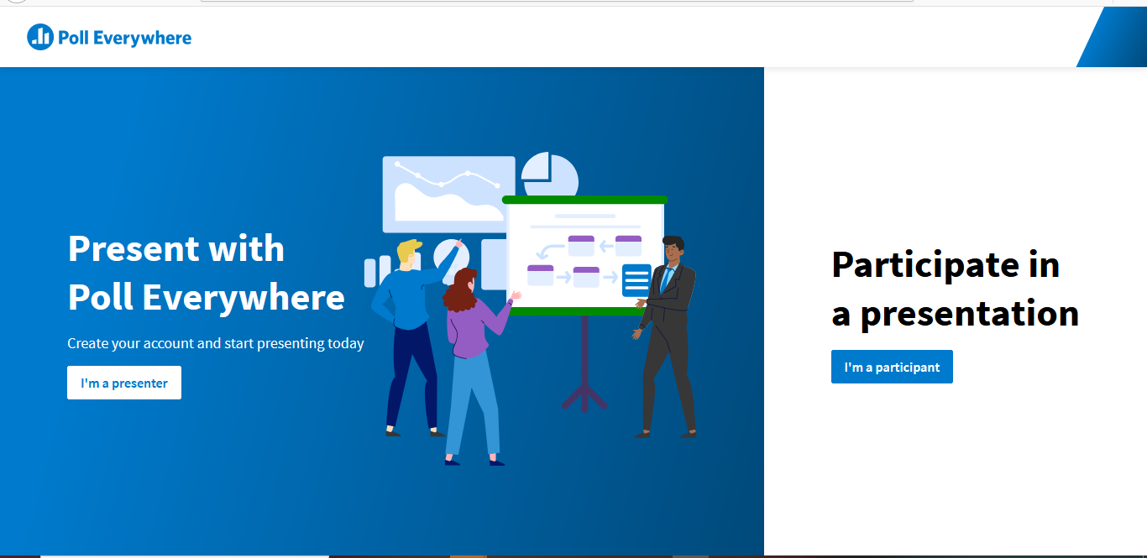

Figure 1

Once you are logged in, please enter “ascccresolut876” into the Username area and click “Join.” (Figure 2)

NOTE: Once you have an account, you can also enter the direct link into your browser: https://pollev.com/ascccresolut876

This link will also be provided in the Zoom chat at the beginning of the Resolutions Session for your convenience.
Figure 2

Preparing to Vote on Poll Everywhere
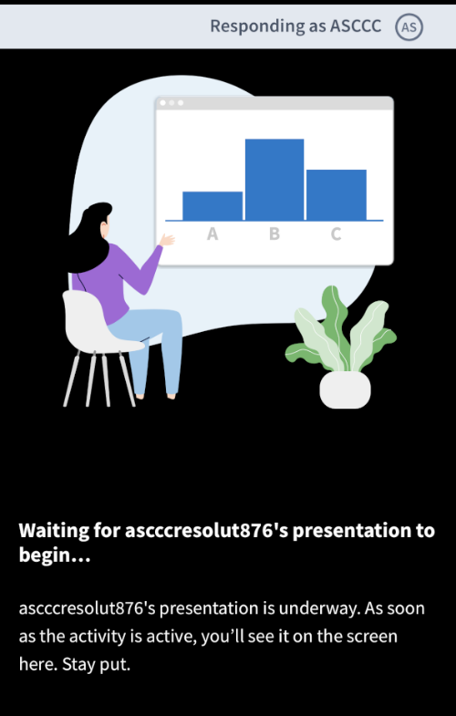
Figure 3
Before voting begins, please update your screen name to be your college. This allows the ASCCC to ensure that only a single delegate is voting during Plenary Sessions. During this Mock Plenary, however, voting is open to all. To change your name to your college name, click on the responding as icon (Figure 3).

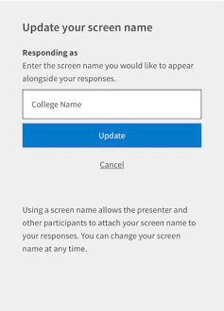
Once you click on this area, you will be prompted to change your “responding as” field. Please enter your college name and select “update” (Figure 4).
Figure 4

Congratulations! You are now ready to vote!
What If I am Experiencing Technical Difficulties?
No problem! We’re here to help. Please send an email to eventtechsupport@asccc.org. Although this email will be actively monitored, your patience is extremely appreciated.

