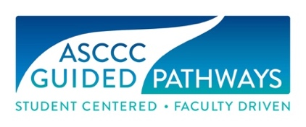

Launching Your Guided Pathways – Where do you start?
Beginning Information and Guided Self Placement Tool

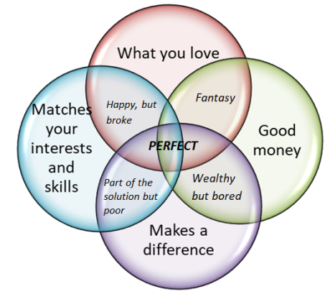

This brief questionnaire will help you consider what you would like for your future and educational planning. Please fill this form and bring it with you to meet with a counselor to prepare for enrolling in courses related to your education goal.
Information/Questions | Your answers
- Name
- Age
- What career(s) are you interested in?
- Why are you interested in these careers? (check all that apply) | - I love the work  - It matches my skills and interests  - It makes a difference in the world  - It will help me make good money  - I do not know why  - My parents told me to do this career  - Write any other reasons
- How confident are you that this is the right career for you? | - Very confident  - Somewhat confident in the choice for now  - Need further exploration  - Currently not sure and cannot make a choice
- If you had to choose an area of interest or pathway which of these might you choose? Number your top three areas of interest or pathways. | - STEM (Science, Technology, Engineering, Math, Computer Science, etc)  - Business, Accounting, Economics  - Education  - Behavioral or Social Sciences (Psychology, Sociology, Public Safety, Communication, Allied Health, Human Resources, Journalism)  - Arts and Humanities (English, Philosophy, Communication, History, Art, Theater, etc)  - Technical Majors (such as Automotive, Electricity, Culinary Arts, Hospitality, Costuming, Welding etc)  - Allied Health Fields (Medicine, Nursing, Radiology, Pharmacy, Physical Therapy, Athletic Training, Dental Hygiene, Respiratory Therapy, etc)  - Don’t know yet  - Some other area not listed:
- Choose an educational goal. | - Obtain an associate degree (AA/ADT) & transfer to a four-year university  - Transfer to a four-year university without a degree  - Obtain an associate degree (AA) without transferring to a university  - Obtain a certificate without transfer to a four-year university  - Explore new options, interests, goals, prepare for a new career  - Advance in my current job – skills builder  - Maintain a license or certification  - Complete High School diploma or GED  - Improve Basic Skills  - Currently enrolled in different university taking a required course  - Undecided/Exploring
- How confident are you that this is the right educational goal for you? | - Very confident  - Somewhat confident in the choice for now  - Need further exploration  - Not sure of my education goal at this point
- What was your last year of school?
- Indicate your High School cumulative GPA. Bring your transcript to your appointment with your counselor. | - 3.6-4.0  - 3.0-3.59  - 2.6-2.99  - 2.3-2.59  - 2.0-2.29  - 1.5-1.99  - Less than 1.49  - I do not know my High School GPA
- English and ESL courses.  Check all that apply. | - I completed high school English  - I took and passed the ERWC (English Reading and Writing Course)  - I have taken ESL courses.  - I have not taken English or ESL courses.
- Math courses | What was the highest mathematics course you took and what was your grade? (Examples of might be Arithmetic, Pre-Algebra, Algebra, Algebra 2 or Intermediate Algebra, Geometry, Trigonometry, Pre-Calculus, Statistics, Calculus, or Integrated Math 1,2, or 3.)
- Check any of the factors that apply to your education | - AP courses  - AP test scores 3, 4, or 5  - CLEP test scores  - Dual enrollment | - Military experience  - Units from college work  - Work experience  - ACT or SAT score
- What general education pattern will you take? | - Local general education – required for local degrees only  - CSU breadth for all ADT and CSU transfer  - IGETC – for UC and CSU transfer  - Science IGETC for certain high unit STEM programs at CSU and UC  - I do not know I need help understanding the general education options and requirements
- English/ESL  This is a self-reflection and you are encouraged to be positive. | Many students are currently able to register for transfer level English. Write a sentence or two about your own confidence and ability to complete college level writing and research assignments.
- Review the college courses and work for Reading, English and/or ESL.  Select a course. | After looking at the English/ESL courses available, the unit and time commitment and success data, please write down the one you feel is best for you and why. Include any questions, concerns or issues?
- Math/Quantitative Reasoning  This is a self-reflection and you are encouraged to be positive. | Reflect on the type of math for your pathway. Write a sentence or two about your confidence and direction with regards to math and quantitative reasoning.
- Look at the course work available for Math/Quantitative Reasoning.  Select a course | After looking at the math/quantitative reasoning courses related to various areas of interest, or pathways, as well as the number of courses, units, time commitment and success data, please write down the course you feel is best for you.
- How confident are you in this selection of career? | - Very confident  - Somewhat confident in the choice for now  - Need further exploration  - Currently not sure and cannot make a choice

- Do you have any thoughts or questions you would like to discuss?

- Take this information and your transcript to your counseling appointment.

