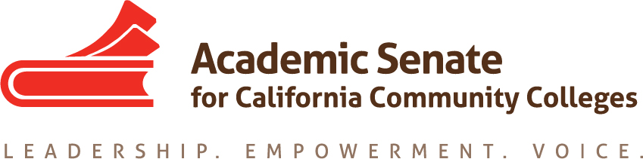

Legislation and Advocacy Committee

2 October 2019, 1:00-2:00pm
Join from PC, Mac, Linux, iOS or Android: https://cccconfer.zoom.us/j/346937688
Or iPhone one-tap (US Toll): +16699006833,346937688# or +16468769923,346937688#
Or Telephone:
+1 669 900 6833 (US Toll)
+1 646 876 9923 (US Toll)
Meeting ID: 346 937 688

AGENDA

- Call to Order and Adoption of the Agenda

- Status of Bills Still in Progress (last date for signing/veto = 13 October 2019)
  - AB1504

- Legislative Goals for 2019-2020
  - Faculty Diversification
  - Combined ASCCC Budget
  - Accessibility
  - Others as determined

- Plenary Planning
  - Breakout is scheduled for Thursday, 7 November from 4:00-5:15pm
  - Dolores, Ginni, Kelly, Erik, Robert(?)
  - See attached PPT from spring

- ASCCC Legislative Advocacy Day – Wednesday, 4 March 2020
  - Training on Tuesday, 3 March 2020
  - Travel arrangements

- Announcements
  - Events
    - Area Meetings – 11 and 12 October 2019, locations vary
    - Executive Committee – 6 November 2019, Newport Beach
    - Fall Plenary – 7-9 November 2019, Newport Beach

- Adjournment

