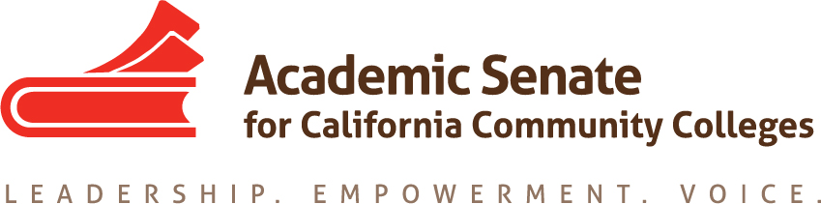

Legislation and Advocacy Committee

DATE: 27 January 2020

TIME: 3:00-4:00pm

CONFERENCE CALL INFORMATION

Join from PC, Mac, Linux, iOS or Android: https://cccconfer.zoom.us/j/229368185

Or iPhone one-tap (US Toll): +16699006833,229368185# or +16468769923,229368185#

Or Telephone:

+1 669 900 6833 (US Toll)

+1 646 876 9923 (US Toll)

Meeting ID: 229 368 185

Minutes

Present: Dolores Davison, Ginni May, Kelly Kulzer, Erik Reese, Robert Stewart, Randy Beach

- Call to Order; Adoption of the Agenda; Notetaker
Ginni May will take minutes.

- Status of Previous Action Items
Dolores Davison discussed the Legislative Advocacy information.
  - Current Cycle
    - Two Year Bills – that may come continue to live: SB291 (Leyva); AB1314 (Medina); AB897 (Medina) we are just watching this one because it falls under working conditions, the CCLC took an opposed position, this bill moved out of appropriations on Thursday – we will just continue to watch;
    - New Legislation – not a lot yet but quite a bit of discussion of bills that could be coming down: SB874 (Hill) a spot bill about the baccalaureate degrees, waited on the release of the report on the Baccalaureate degrees, this report can be found here. The tone of the report was interesting, and not real supportive of the baccalaureate degree programs. Interest in a bill on part-time office hours, again we would watch and most likely not take a position; a bill on student housing may come forward again; interest in giving both students a vote on the BoG and equitize role of students on local governing boards;
    - January Budget Update – Discussion about the requests and needs of the CCCs took place. There is hope that some of the requests will be met in the May-Revise. The SCFF and Calbright funding did not change in the January Governor’s Budget. There will be a hearing on Calbright, where the ASCCC has been asked to provide testimony around curriculum, accreditation, and role of the academic senate. Title 5 §51016 requires that the Board of Governors recognizes the accrediting commission that accredits a CCC.
ACTION: Check to see what the Apprentice Council is looking for in regard to budget, budget issues on CBE and Workplace learning.

- Legislative and Advocacy Day
  - Travel:
    - Rooms will be reserved at the hotel for Tuesday, 3 March for all committee members
    - Flights need to be booked by the individual and will be reimbursed; same for driving.
  - Training: 3-6pm on 3 March, location TBD; dinner to follow immediately after – Evan Hawkins, FACCC Executive Director and Wendy Brill-Wynkoop, FACCC Board member will do the training; dinner to follow
  - Actual Leg Visits: Meet morning of on 6th floor of the Capitol in the café to review visits and discuss visits - Plan to be available 8:00-4:00 on that day; each group will be led by an ASCCC officer and will include an Executive Committee member and a LAC Committee member. Expect to do about 4 visits per team.
  - Depending on flights, possible debrief after visits

- Plenary Planning
  - Legislative and Budget Update breakout on Thursday morning (16 April)
Same breakout as in fall except with new legislation.
Robert will be there, Kelly is a firm probably, Erik is a probably, Randy is a no
- Other Legislative Efforts at this point
  - CCLC Conference – just finished this morning
  - ACCT Visit in Washington DC – Dolores and Ginni are both attending
  - FACCC A&P Conference (8-9 March) – takes place right after the ASCCC Legislative days, ASCCC does not advocacy visits during this event
  - ICAS Legislative Day (10 March) – advocacy visits will take place with CSU and UC academic senate colleagues

- Announcements
  - Events
    - Executive Committee Meeting, 7-8 February, San Jose Marriott
    - Accreditation Institute, 21-22 March, Marriott La Jolla
    - Executive Committee Meeting, 6-7 March, North Orange Continuing Education
    - Diversity Summit, 19-20 March, Sawyer Kimpton Sacramento
    - Area Meetings, 27-28 March (Madera/Foothill, LA Southwest/Long Beach)
    - Executive Committee Meeting, 15 April, Oakland Marriott
    - Spring Plenary Session, 16-18 April, Oakland Marriott

- Adjournment – 4:13 pm

