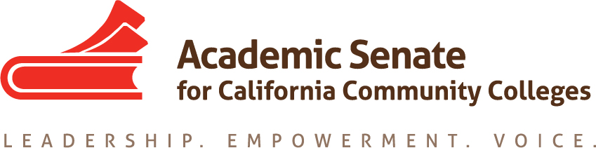

LEGISLATIVE AND ADVOCACY COMMITTEE

Monday, October 19 2015

11:00am – 1:00pm

MINUTES

- Call to Order: 11:02am
- Members present: Julie Bruno, Dolores Davison, Sam Foster, Kelsey Iino, David Morse, Stacey Searl-Chapin
- Approval of the Agenda --approved
- Approval of the September Minutes (Attachment: September 28, 2015 minutes)-- approved
- Discussion items, with action as needed
  - Legislative Agenda (Attachment: Legislation Report) – Committee members discussed clarifying the ASCCC’s role in advocacy regarding legislation. Once clarified, it would be useful to include a statement on website.
    - ASCCC Legislative Topics:
      - Audit Fee – the audit fee has long been considered an option for colleges to serve students who may not need course credit but would benefit from practice to prepare for a licensure or certification exam or as a refresher prior to taking a subsequent course. However, the low fee of $15 per unit (Ed Code 76370) frequently acts as a deterrent and many colleges have eliminated auditing. An increase in the audit fee will to allow colleges to recover some cost of serving this student population.
      - Stand Alone course approval – Sunset date January 1, 2014. There is system-wide interest in restoring stand-alone course approval.
      - Mental Health Services – possibly partner with FACCC and other system partners to work with on this issue.
      - Campus safety – issues around safety of students and staff.
      - Online Educational Resources (OER) – perhaps legislation specifically for the CCCs or depending on what happens with AB 798, possibly follow up legislation.
      - Additional proposals brought forward at the State Legislative Program Task Force meeting included a proposal to address part time issues from CFT (revisiting of AB 1010 from the last legislative session, which the CCCCO is inclined to look at as a bargaining issue) and a proposal to add stakeholders in the adult education consortia (some Task Force members voiced concerns that it would slow processes down with too many people, but the ASCCC supports including representation from a variety of interested groups, as appropriate).
      - LAC to recommend to the Executive Committee the initial legislative agenda to include the following topics: audit fee, stand-alone course approval, mental health services, campus safety and OER.
  - Resolutions (Attachment: LAC Priorities and Resolutions) - Members review the resolution spreadsheet and agreed that the loan forgiveness resolution; 6.05 (S15) is completed. Bruno and Davison are researching 9.04 (S99).
  - Plenary Legislative and Advocacy Breakout – Members agreed that the breakout will provide a legislation update. Mike Magee, Director of CO State Government Relations, and Shaaron Vogel, President of FACCC, have agreed to serve as presenters. The breakout will also cover ASCCC advocacy work including the legislative liaison position and legislative update webpage.
  - Instructional Design and Innovation Institute
    - Civic Engagement Proposals – The Civic Engagement and Citizenship Workgroup (Julie Adams, Manuel Baca, Julie Bruno, Dolores Davison, Stacey Searl-Chapin, and Patty Robinson) proposed a 15-minute general session presentation and then breakout session for the IDII.
    - No other proposals suggested
  - Legislative Liaison Position (Attachment: Legislative Liaison Position Draft)— Bruno contacted Paul Setziol (De Anza) and Curtis Martin (Modesto) for feedback on the position expectations and both provided edits and suggestions. Committee members discussed new considerations including the notion that the position may be a group of faculty rather than just one person. Members suggested a Rostrum article to publicize the position. Bruno will edit the draft based on members’ feedback and bring the position guidelines to the ASCCC Executive Committee in November for approval.
  - ASCCC Advocacy Day: Members discussed the different formats this type of event might take such as traveling between offices to speak to legislative aides or reserving a room in the capital for legislators and aides to meet with ASCCC (both formats have positives and negatives) as well as meeting with other groups (DoF, LAO, etc). Who will be involved in the visits will be determined and may include LAC members, ASCCC Executive Committee members or a combination of the two committees. Members thought that an April visit might be useful. Bruno will bring a proposal to the ASCCC Executive Committee in November for approval. Members will discuss specifics of the visit during the December LAC meeting and requested an invitation for Jonathan Lightman from FACCC to attend, if possible.
- Events: Members were reminded of the upcoming ASCCC events.
  - Executive Committee – November 4, Marriott Irvine
  - Area Meetings – October 23, North
October 24, South
  - Fall Plenary – November 5-7, Marriott Irvine
  - Curriculum Regional (North) – November 13, Solano College
  - Curriculum Regional (South) – November 14, Mt. San Antonio College
  - Instructional Design and Innovation – January 21-23, Riverside Convention Center
- Other – in person meeting December 9, 2015 at the ASCCC office.
- Adjournment – 12:23pm

