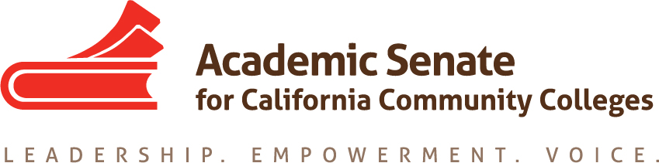

LEGISLATIVE AND ADVOCACY COMMITTEE

Tuesday, February 2, 2016

12:30pm – 2:30pm

Minutes

- Call to Order at 12:35pm
- Welcome
- Members present: Julie Adams, Julie Bruno, Dolores Davison, Sam Foster, Kelsey Iino, David Morse, Stacey Searl-Chapin
- Approval of the Agenda – by consensus
- Approval of the December Minutes (Attachment: December minutes) by consensus
- Discussion items, with action as needed
  - Legislative Agenda Update
    - Audit Fee – The Chancellor’s Office has determined that it would be best to pursue a change through budget trailer language rather than separate legislation; Bruno will touch base with Vice Chancellor Vince Stewart to obtain an update.
    - Stand Alone Course Approval – The System Advisory Committee on Curriculum is working this issue. The Chancellor’s Office is considering a change in regulation or legislation.
    - Mental Health Service – AB 2017 (McCarty) is a grant program mental health services to be funded by moving money from counties to the colleges. (FACCC supports)
    - Additional items
      - OER – Morse assisted on a breakout at CCLC with a representative from Open Stax to get colleges onboard in using OERs. Dan Crump also attended the breakout and alleviated concerns regarding deadlines and grant funds. The ASCCC Executive Committee convened an OER task force to work with CCLC and students to create an initiative on OER without the involvement of the CSUs. Additionally, the task force will analyze Z Degrees proposals. ASCCC leadership is in conversations with staff in the Governor’s Office regarding the $5 million in budget for Z degrees. Staff clarified that the money is for the development of Z degrees but OER is necessary for those, so if the ASCCC develops a proposal on OER and it is something that the Governor could support, funding could follow.
      - Campus Safety – This seems to have stalled. The Chancellor’s Office has not convened a task force although it has been part of the mental health discussion. Bruno will get an update.
      - AA to MA – The task force is meeting on 9 February although the issue is still in preliminary stages in discussion. A program might not require legislation because there might not be legal barriers. The Chancellor’s Office is reviewing Ed Code section 61698 that outlines the loan forgiveness programs for those who return to teach at our public institutions.
  - FACCC Update (D. Davison) – Davison provided an update on the FACCC meeting. FACCC is focused on the mental health legislation (AB 2017, McCarty) and part time working conditions (AB 1690, Medina; AB 2069, Medina; and AB 626, Low). FACCC leadership traveled to Washington, DC to meet with legislators)
  - CCLC – The CCLC Advisory Committee on Legislation met during the CCLC conference. The League will oppose AB 1690 (Medina) as currently written. However, they are willing to consider alternative options to support part time faculty. The League’s leadership is reaching out to the author to see if there is common ground. The League is sponsoring three new bills -- all have to do with Cal Grants and BoG fee waivers (all carried by Medina).
  - Proposed Legislation and conversations with government officials
    - Z-Degrees – There is significant interest from a number of organizations and individuals on establishing Z degrees in the CCCs. Morse and Bruno were contacted by the Governor’s staff to review the language in the budget trailer bill. The intent is to move students through with minimal costs however the language was concerning for a few reasons especially regarding local implementation. The Governor’s Office is open to suggestions and Morse and Bruno will continue to work with the staff as well as the Chancellor’s Office.
    - UCTP – Bruno and Erik Shearer presented on the UCTPs at CCLC and were approached by legislator’s staff who is very interested in the implementation and results of the UCTP. The legislator wants to see if the pathways make a difference for students and is trying to figure out how the legislature can help ensure a successful result.
    - Other –
      - Morse and Bruno spoke with the LAO and suggested that the CCCs might need to think about creation rather than promotion of OER. It would be useful to get faculty together to work towards creation of appropriate materials.
      - Morse updated the committee on legislation regarding equalizing service credits for non-credit faculty with regular faculty
      - Morse has been in conversation with Bonilla’s office regarding student access codes for instructional materials.
      - The committee discussed the implementation of Workforce Task Force recommendations including how the implementation will work and whether to expect legislation.
  - ASCCC Advocacy Day – Jonathan Lightman will be training the Executive and Legislative Committee on 29 April. Adams suggested having the training at the Chancellor’s Office. Bruno will reach out to Vice Chancellor Vince Stewart to see if he can attend in the morning. Bruno spoke with Dean Flores (Senator) who suggested that the ASCCC focus advocacy efforts on professional development (legislators don’t know how much we do with and for faculty). Committee members discussed having an all day event with teams (probably 10-3 in Sacramento).
  - Resolutions and Priorities (Attachment: LAC Priorities and Resolutions) – Committee members reviewed the spreadsheet.
  - Legislative Liaison Position Update – Bruno wrote an article in Rostrum for all three liaison positions; page on all liaisons on website (is live). The committee will discuss how to use the liaisons at the next meeting.
- Spring 2016 Plenary
  - Breakouts – Bruno submitted a Legislation and Advocacy Breakout for spring plenary.
  - Resolutions – none at this point
- Events:
  - Accreditation Institute – February 19-20, Marriott Mission Valley - San Diego
  - Academic Academy – March 17-19, Sheraton Sacramento
  - ASCCC Spring Plenary – April 21-23, Sacramento Convention Center
- Other
- Adjournment – 1:40pm

