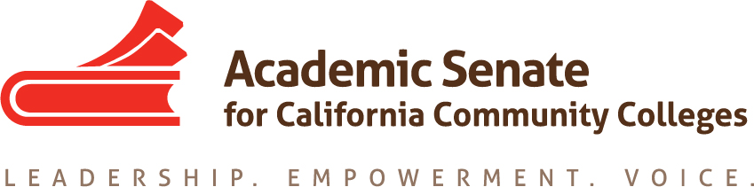

RELATIONS TO LOCAL SENATES COMMITTEE

September 11, 2017

12:15 PM – 1:00 PM
Zoom Teleconference Information
Join from PC, Mac, Linux, iOS or Android: https://zoom.us/j/935530855
Or iPhone one-tap: US: +14157629988,,935530855# or +16465687788,,935530855#
Or Telephone: Dial(for higher quality, dial a number based on your current location)：
US: +1 415 762 9988 or +1 646 568 7788
Meeting ID: 935 530 855
MINUTES

Members Present: Rebecca Eikey, Lee Gordon, Leigh Anne Shaw, Peggy Campo, Carrie Roberson, Cheryl Aschenbach
- Call to Order
- Note Taker: Rebecca Eikey
- Adoption of the Agenda: Approved as presented (not formal motion, by consensus)
- Approval of Minutes from August 21, 2017: Approved as presented (not formal motion, by consensus)
- Meeting Schedule 2017-2018
  - Teleconference/Phone meetings – October, March, April: Discussed mid-October as next meeting; Rebecca will send out a Doodle Poll
  - In-Person meeting(s) – January 17, 2018 – location TBD: Possible meeting locations such as Skyline College or Sacramento; ACTION: Rebecca will follow up with ASCCC office to see if how we can meet in Sacramento at the Chancellor’s Office.
- Status of Previous Action Items
  - Assigned Tasks
    - Leadership Survey Results (Leadership Institute 2017): Discussed the results of the Leadership Survey. The survey was given to participants of the 2017 Leadership Institute as a way of having initial results that could help guide the work of the committee; the committee agreed that the results indicated that local senate leaders need assistance when issues arise locally, which seems more like Technical Assistance Request; most respondents do not conduct local senate training; other feedback included that even though respondents have access to local leaders, they were interested in regional support; the committee wondered if a PDC module could be developed for this; however the Leadership Academy already exists, do local leader know about this and use it? The committee also discussed whether or not the survey should be repeated with the field as not all of the respondents were local senate presidents. It was agreed that it should.
ACTION: Rebecca will follow up with ASCCC office to see if a survey can be sent to the field for local senate presidents only.

Data & Progress on Short Term & Long Term Plan (local visit planning/discussion) The Executive Committee would like this committee to develop guidelines for local senate visits, including sample letters. A draft of what the RwLS committee developed last year will be reviewed at their next meeting.
ACTION: Rebecca will send the committee a draft of the guidelines.

- Fall 2017 Plenary Planning
  - Break-out session topic(s): The committee discussed possible titles for the Breakout Sessions such as Senate ABCs for New Leaders including Navigating Plenary and Accessing ASCCC Resources” with perhaps a resource for each letter of the alphabet; the committee discussed how the second Breakout session (follow up to the Leadership Institute: “Attended Faculty Leadership but Still have Questions”) could have a less formal format (start with key tenets and ensure time for discussion which would include activities to get the participants involved, such as fill out cards with “one-burning question” and organizing the questions into categories or themes; or having posters with certain topics related to the survey; the committee agreed that reviewing Plenary Breakout descriptions can be done via email.
  - Newbie Breakfast: This will be a Meet and Greet and will include members of the Executive Committee; there was concern about attendance; however it was understood that the Meet & Greet room would be near the registration desk; there was a question about having “First-Timers” as a flag for badges.
ACTION: Rebecca will follow up with ASCCC office about “First-Timers” as a flag for badges.
  - Other ideas: not discussed
- Announcements and Events
  - ASCCC Executive Committee Meeting, September 29-30, 2017
  - ASCCC Area Meetings October 13 and 14, 2017
  - ASCCC Executive Committee Meeting, November 1, 2017
  - ASCCC Fall Plenary, November 2-4, 2017

- Adjournment

Status of Previous Action Items

- In Progress
1. Rostrum Article related to Spring 2015 Resolution 17.04 “Collegial Consultation with Local Senates on Student Learning Outcomes Policies and Procedures”

- Completed

